An Interactive Real-Time System for Tracking and
Analyzing Weather and Pollution Patterns

Course Code: PROJ CS881 Course Name: Project - III

Major Project submitted
in
partial fulfilment of the requirements of the degree
of

Bachelor of Technology
in
Computer Science and Engineering
by
SANDIP KUNDU — 27600122033
ADITYA SHEE — 27600122107
RAJAN MANDAL — 27600122144
ANIKET KUMAR — 27600122147
PRANAB KUMAR GHOSH — 27600122206
under the guidance of

Professor Sagar Chakraborty

(Department of Computer Science and Engineering)


BUDGE BUDGE INSTITUTE OF TECHNOLOGY

Affiliated to MAKAUT (formerly WBUT) & Approved by AICTE, NAAC Accredited, Recognized by “UGC section 2f” with AISHECODE–C-6239 Kolkata - 700 137, West Bengal, India Phone:0332 4820676 / 0670
http://www.bbit.edu.in

July 20, 2026

DECLARATION

We hereby declare that the project work entitled "An Interactive Real-Time System for Tracking and Analysing Weather and Pollution Patterns" submitted to Budge Budge Institute of Technology is our original work, carried out under the guidance and supervision of Prof. Sagar Chakraborty in partial fulfillment of the requirements for the award of the degree of Bachelor of Technology (B.Tech.) in Computer Science & Engineering.

We further declare that this project report has not been submitted, either in whole or in part, to any other university or institution for the award of any degree, diploma, or other academic qualification. All sources of information and references used in this report have been duly acknowledged.

Place: Budge Budge Institute of Technology, Kolkata
Date: _________________

Student Details:
Name: _________________ Roll No.: _________________ Signature: _________________
Name: _________________ Roll No.: _________________ Signature: _________________
Name: _________________ Roll No.: _________________ Signature: _________________
Name: _________________ Roll No.: _________________ Signature: _________________
Name: _________________ Roll No.: _________________ Signature: _________________

Sandip Kundu (URN- 27600122033)
Aditya Shee (URN- 27600122107)
Rajan Mandal (URN- 27600122144)
Aniket Kumar (URN- 27600122147)
Pranab Kumar Ghosh (URN- 27600122206)

B-Tech 4th Year
(2025-2026) (ODD SEMESTER)
NO-PLAGIARISM DECLARATION

Title of the Project: An Interactive Real-Time System for Tracking and Analysing Weather and Pollution Patterns
Name(s) and URN(s) of the Student(s):
- Sandip Kundu (URN- 27600122033)
- Aditya Shee (URN- 27600122107)
- Rajan Mandal (URN- 27600122144)
- Aniket Kumar (URN- 27600122147)
- Pranab Kumar Ghosh (URN- 27600122206)

- Name of Project Supervisor: Prof. Sagar Chakraborty

We hereby declare that this Project Report entitled "An Interactive Real-Time System for Tracking and Analysing Weather and Pollution Patterns" is the result of our original work carried out under the guidance and supervision of Prof. Sagar Chakraborty in partial fulfillment of the requirements for the award of the degree of Bachelor of Technology (B.Tech.) in Computer Science & Engineering.

We further declare that this report has been prepared by us independently and that all information, ideas, data, references, and materials obtained from books, journals, research papers, websites, and other sources have been properly acknowledged and cited wherever applicable. No part of this report has been copied, reproduced, or submitted previously for the award of any degree, diploma, or any other academic qualification at this or any other institution.

We understand that plagiarism is a serious academic offence and may result in rejection of the project report and appropriate action as per institutional and university rules.

Signature of Students :
Name | Signature
Sandip Kundu | __________________
Aditya Shee | __________________
Rajan Mandal | __________________
Aniket Kumar | __________________
Pranab Kumar Ghosh | __________________

Date: __________________
Place: Budge Budge Institute of Technology, Kolkata

BUDGE BUDGE INSTITUTE OF TECHNOLOGY
Department Of CSE (B. Tech)
CERTIFICATE OF APPROVAL
This is to certify that the project work entitled " An Interactive Real-Time System for Tracking and Analysing Weather and Pollution Patterns " submitted by:

- Mr. Sandip Kundu (Roll No.: 27600122033)
- Mr. Aditya Shee (Roll No.: 27600122107)
- Mr. Rajan Mandal (Roll No.: 27600122144)
- Mr. Aniket Kumar (Roll No.: 27600122147)
- Mr. Pranab Kumar Ghosh (Roll No.: 27600122206)

in partial fulfillment of the requirements for the award of the degree of Bachelor of Technology in Computer Science & Engineering from Maulana Abul Kalam Azad University of Technology (MAKAUT), has been carried out under my supervision.

The project embodies the results of investigations conducted by the students during the prescribed period as full-time students of the Department of Computer Science & Engineering at Budge Budge Institute of Technology.

The Final Year Project (Project-III) has been approved as it satisfies the academic requirements with respect to the project work prescribed for the said degree.

Approved by the following panel of examiners:

S.N | Name | Designation | Signature | Date
1. | Prof. Sagar Chakraborty | Project Supervisor
2. | Prof. Sagar Chakraborty | HOD (CSE)

ACKNOWLEDGEMENT

The successful completion of this project, undertaken in partial ful-fillment of the requirements for the degree of Bachelor of Technology in Computer Science & Engineering (B.Tech), would not have been possible without the guidance, support, and encouragement of several individuals and institutions.
We would like to express our sincere gratitude to Maulana Abul Kalam Azad University of Technology (MAKAUT) for designing a comprehensive curriculum that provided us with the opportunity to undertake this meaningful project work.
We are deeply indebted to Budge Budge Institute of Technology for providing us with the necessary infrastructure, resources, and academic environment conducive to research and innovation.
We extend our heartfelt gratitude to our project supervisor, Prof. Sagar Chakraborty, for his invaluable guidance, continuous support, and constructive feedback throughout the course of this project. His expertise and encouragement have been instrumental in shaping this work and ensuring its successful completion.
We would like to express our sincere appreciation to Prof. Sagar Chakraborty, Head of the Department (Computer Science & Engineering), for his encouragement, administrative support, and for taking time to evaluate our work as an external examiner. His professional insights and valuable suggestions have greatly enhanced the quality of this project.
We are also grateful to all the faculty members of the Department of Computer Science & Engineering for their academic support and encouragement during our undergraduate studies.
Finally, we would like to thank our family, friends, and everyone who directly or indirectly contributed to the successful completion of this project. This project has been a wonderful experience where we have learnt and experienced many beneficial things.

With Regards
Sandip Kundu (Roll No.: 27600122033)
Aditya Shee (Roll No.: 27600122107)
Rajan Mandal (Roll No.: 27600122144)
Aniket Kumar (Roll No.: 27600122147)
Pranab Kumar Ghosh (Roll No.: 27600122206)

B-Tech 4th Year (2025-2026)

ABSTRACT

Environmental pollution and changing weather conditions have become major global concerns due to their significant impact on public health, ecosystems, and sustainable development. This project, "An Interactive Real-Time System for Tracking and Analysing Weather and Pollution Patterns," presents a comprehensive web-based platform developed using the MERN stack (MongoDB, Express.js, React.js, and Node.js) to provide real-time environmental monitoring, forecasting, visualization, and data analysis through a modern and user-friendly interface.

The application integrates the OpenWeather API to collect real-time weather information, including temperature, humidity, atmospheric pressure, wind speed, and weather conditions. Using the geographical coordinates obtained from the weather data, the system simultaneously retrieves air pollution parameters such as Air Quality Index (AQI), PM2.5, PM10, CO, NO₂, O₃, and SO₂, providing users with a comprehensive overview of atmospheric conditions. The collected information is securely stored in MongoDB and presented through interactive visualizations using Chart.js, enabling users to analyse environmental trends effectively.

To enhance user engagement and research collaboration, the platform incorporates a secure authentication system that enables users to register, log in, manage personal profiles, save preferred locations, and download historical datasets for offline analysis. The application also provides an integrated communication platform featuring real-time messaging, media sharing, and calling facilities, allowing researchers, environmental analysts, and other registered users to collaborate effectively. In addition, a built-in social media and blogging module enables users to publish environmental updates, awareness posts, research findings, and community discussions, thereby encouraging knowledge sharing and public participation.

A significant contribution of the proposed system is its forecasting capability. The platform includes an AQI forecasting module that predicts future air quality trends based on seasonal patterns for selected locations and dates, as well as a weather forecasting module capable of providing 24-hour and 6-day forecasts, helping users anticipate future atmospheric conditions and plan accordingly.

Furthermore, the system incorporates a dedicated Data Analyst Portal, where environmental datasets can be explored through exploratory data analysis (EDA), interactive visualizations, and intelligent analytical insights. By examining relationships between weather variables and pollution levels, the analytical module identifies meaningful trends, highlights significant environmental changes, and generates data-driven observations that support informed decision-making and environmental research.

Overall, the proposed system successfully combines real-time data acquisition, predictive analytics, interactive visualization, collaborative communication, and intelligent data analysis into a unified platform that supports environmental monitoring, research, public awareness, and informed decision-making.

LIST OF CONTENTS

DECLARATION ................................................................................................................................... ii
NO-PLAGIARISM DECLARATION ................................................................................................. iii
CERTIFICATE OF APPROVAL ....................................................................................................... iv
ACKNOWLEDGEMENT ................................................................................................................... v
ABSTRACT .......................................................................................................................................... vi
LIST OF CONTENTS ......................................................................................................................... vii
LIST OF ILLUSTRATIONS ................................................................................................................ xi

CHAPTER - 1: INTRODUCTION ............................................................................................... 1 - 5
1.1 Introduction to An Interactive Real-Time System for Tracking and Analysing Weather and
Pollution Patterns ..................................................................................................................... 1 - 2
1.2 Overview of the Topic .................................................................................................................. 3
1.3 Literature Review ......................................................................................................................... 4
1.4 Literary Survey / Existing Systems Survey .................................................................................. 5

CHAPTER-2: OBJECTIVES OF THE STUDY .......................................................................... 6 - 9
2.1 Introduction .................................................................................................................................. 6
2.2 Primary Objective ........................................................................................................................ 6
2.3 Secondary Objectives ............................................................................................................. 6 - 7
2.4 Features of the Project ............................................................................................................ 7 - 8
2.5 Scope of the Application ........................................................................................................ 8 - 9
2.6 Expected Outcomes ..................................................................................................................... 9

CHAPTER-3: PROBLEM STATEMENT ................................................................................ 10 - 12
3.1 Introduction ............................................................................................................................... 10
3.2 Existing Problems .............................................................................................................. 10 - 11
3.3 Problem Statement ............................................................................................................. 11 - 12
3.4 Need for the Proposed System .................................................................................................. 12
CHAPTER - 4: RESEARCH METHODOLOGY AND SYSTEM ARCHITECTURE …... 13 - 20
4.1 Introduction .............................................................................................................................. 13
4.2 System Development Methodology ................................................................................. 14 - 15
4.4 System Architecture ................................................................................................................ 16
4.5 Data Collection Method ................................................................................................... 16 - 17
4.6 Data Collection Tools ............................................................................................................. 17
4.7 Development & Analytical Tools Used ................................................................................. 18
4.7.1 Development Tools & Technologies ......................................................................... 18
4.7.2 Analytical Tools & Technologies .............................................................................. 18
4.8 Functional Module Design .................................................................................................... 19
4.9 Use Case Diagram ................................................................................................................. 20

CHAPTER - 5: DATA ANALYSIS & INTERPRETATION ............................................... 21 - 39
5.1 Introduction ........................................................................................................................... 21
5.2 Exploratory Data Analysis (EDA) ................................................................................. 21 - 23
5.2.1 Dataset Description ................................................................................................... 21
5.2.2 Main Components ..................................................................................................... 21
5.2.3 Important Columns ................................................................................................... 21
5.2.4 Initial Data Exploration ............................................................................................ 22
5.2.5 Missing Value Analysis ........................................................................................... 22
5.2.6 Duplicate Record Handling ..................................................................................... 22
5.2.7 Data Cleaning and Preprocessing ..................................................................... 22 - 23
5.2.8 Data Type Standardization ...................................................................................... 23
5.2.9 Feature Engineering (AQI Categorization) ............................................................. 23
5.2.10 Distribution Analysis ............................................................................................ 23
5.2.11 City-Wise AQI Analysis ...................................................................................... 23
5.2.12 Bias Handling ...................................................................................................... 23
5.2.13 Visualization Strategy ......................................................................................... 23
5.3 EDA Screenshot with Insights Information & Conclusion ........................................... 24 - 36
5.3.1 Weather Analysis ................................................................................................ 24 - 29
5.3.2 Pollution Analysis ................................................................................................ 30 - 33
5.3.3 AQI vs. Pollution Analysis .................................................................................. 34 - 36
5.2.4 Pollution Analysis (Line Chart) .................................................................................. 36 - 37
5.2.5 Forecasting Analysis .................................................................................................. 37 - 39
5.7 Chapter Summary ................................................................................................................. 39

CHAPTER - 6: DISCUSSION AND RESULTS ................................................................ 40 - 46
6.1 Introduction ......................................................................................................................... 40
6.2 Results of the Proposed System ................................................................................... 40 - 44
6.2.1 Home Page ............................................................................................................... 40
6.2.2 User Authentication Module .................................................................................... 41
6.2.3 Community Chat System .................................................................................. 41 - 42
6.2.4 Analysis & Insights Repository ............................................................................... 42
6.2.5 AQI Forecasting System .......................................................................................... 43
6.2.6 Weather Forecasting System ............................................................................ 43 - 44
6.2.7 Visualization & Trend Analysis .............................................................................. 44
6.3 Comparative Analysis with Existing Applications ...................................................... 45 - 46

CHAPTER-7: CONCLUSION AND LESSONS LEARNT ............................................... 47 - 48
7.1 Conclusion .......................................................................................................................... 47
7.2 Lessons Learnt .................................................................................................................... 48

CHAPTER - 8: RECOMMENDATIONS & SUGGESTIONS ......................................... 49 - 50
8.1 Recommendations .............................................................................................................. 49
8.2 Future Scope ...................................................................................................................... 50

REFERENCES ............................................................................................................................. 51

APPENDICES / ANNEXURES ........................................................................................... 52 - 56
Appendix A – Project Development Timeline ................................................................... 52 - 54
A.1 Overview .................................................................................................................... 52
A.2 Phase-wise Summary .......................................................................................... 52 - 53
A.3 Detailed Week-wise Log ..................................................................................... 53 – 54

Appendix B – Development Tools, Technologies & Package Versions ............................. 54 - 56
B.1 Overview ..................................................................................................................... 54
B.2 Development Environment & Version Control ................................................... 54 - 55
B.3 Database Layer ............................................................................................................ 55
B.4 Frontend Stack ............................................................................................................ 55
B.5 Backend Stack ............................................................................................................ 55
B.6 Real-Time Communication ........................................................................................ 56
B.7 Authentication & Security .......................................................................................... 56
B.8 File & Media Handling .............................................................................................. 56
B.9 API Communication & External Data ....................................................................... 56
B.10 Code Quality & Development Tools ....................................................................... 56

LIST OF ILLUSTRATIONS

Sl. No. | Figure No. | Title of Illustration | Page No.
1. | Figure 4.1 | Flow Chart: Workflow of web application | 13
2. | Figure 4.2 | Flow Chart: System Development | 14
3. | Figure 4.9 | Use Case Diagram | 20
4. | Figure 5.3.1 A | Histogram with Kernel Density Estimation (KDE) | 24
5. | Figure 5.3.1 B | Scatter plot with marginal histograms | 24
6. | Figure 5.3.1 C | Frequency of Different Weather Conditions | 25
7. | Figure 5.3.1 D | City-wise Occurrence of Haze Weather Conditions For Top 10 | 25
8. | Figure 5.3.1 E | Top Months with Highest Haze Occurrence in Bhopal | 26
9. | Figure 5.3.1 F | PM 2.5 levels on Haze and Non-Haze days in Bhopal | 26
10. | Figure 5.3.1 G | Humidity Levels on Haze and Non-Haze days in Bhopal | 27
11. | Figure 5.3.1 H | Wind Speed (m/s) on Haze and Non-Haze days in Bhopal | 27
12. | Figure 5.3.1 I | Top 5 Hottest & Coldest Cities by Avg. Temperature | 28
13. | Figure 5.3.1 J | Top 5 Hottest & Coldest States by Avg. Temperature | 29
14. | Figure 5.3.2 A | Top 10 most polluted cities (PM2.5 concentration) | 30
15. | Figure 5.3.2 B | Pollutant Correlation heatmap | 30
16. | Figure 5.3.2 C | Top 5 Cities by Average PM 2.5 & PM 10 | 31
17. | Figure 5.3.2 D | Relationship between Temperature & PM 2.5 concentration | 32
18. | Figure 5.3.2 E | Relationship between Windspeed & PM 2.5 concentration | 32
19. | Figure 5.3.2 F | Relationship between Humidity & PM 2.5 concentration | 33
20. | Figure 5.3.2 G | Overall Relationship between PM2.5 concentration & temperature | 33
21. | Figure 5.3.3 A | Proportion of Very Poor and Severe AQI Records | 34
22. | Figure 5.3.3 B | Top 10 cities with Highest Avg. AQI | 34
23. | Figure 5.3.3 C | Average PM2.5 Concentration Across AQI Categories | 35
24. | Figure 5.3.3 D | Relationship Between AQI and Temperature | 35
25. | Figure 5.3.3 E | City-wise Distribution of AQI Values | 35
26. | Figure 5.3.4 | Monthly Avg. PM2.5 & PM10 Levels in Kolkata | 36
27. | Figure 5.3.5 A | Kolkata AQI Forecast | 37
28. | Figure 5.3.5 B | Ahmedabad Temperature Forecast | 38
29. | Figure 5.3.5 C | Goa Temperature Forecast (2023-07-30) | 39
30. | Figure 6.2.1 | Home Page of ClimaSphere | 40
31 | Figure 6.2.2 | User Authentication (Sign In / Sign Up) Page | 41
32. | Figure 6.2.3 | Community Chat Module | 41
33. | Figure 6.2.4 | Analysis & Insights Repository | 42
34. | Figure 6.2.5 | AQI Forecasting Platform | 43
35. | Figure 6.2.6 | Weather Forecasting Dashboard | 44
36. | Figure 6.2.7 | Visualization & Trend Analysis | 44

CHAPTER-1: INTRODUCTION

  - Introduction to An Interactive Real-Time System for Tracking and Analysing Weather and Pollution Patterns

Environmental sustainability has become one of the most significant global concerns of the twenty-first century. Rapid urbanization, industrial expansion, increasing vehicular emissions, deforestation, and changing climatic conditions have contributed substantially to the deterioration of environmental quality across the world. Among these challenges, air pollution and unpredictable weather patterns have emerged as critical issues affecting human health, ecological balance, agriculture, transportation, and economic development. According to various environmental studies, prolonged exposure to pollutants such as particulate matter (PM2.5 and PM10), nitrogen dioxide (NO₂), sulphur dioxide (SO₂), carbon monoxide (CO), and ozone (O₃) can cause severe respiratory and cardiovascular diseases while also reducing the overall quality of life. Consequently, timely access to reliable environmental information has become increasingly important for individuals, researchers, environmental organizations, and government agencies to support informed decision-making and sustainable environmental management.

In recent years, advances in cloud computing, web technologies, Internet-based services, and Application Programming Interfaces (APIs) have significantly improved the accessibility of real-time environmental data. Weather forecasts and air quality information are now available to millions of users through digital platforms, enabling people to monitor atmospheric conditions with greater convenience than ever before. Beyond everyday usage, environmental information has become an essential resource for scientific research, disaster preparedness, urban planning, public health management, transportation, agriculture, and climate-related studies. The growing dependence on accurate environmental information highlights the need for intelligent systems capable of not only presenting current conditions but also supporting analytical interpretation and future prediction.

Despite the availability of numerous weather forecasting and air quality applications, most existing systems primarily concentrate on displaying real-time weather information or basic Air Quality Index (AQI) values. While these platforms provide useful environmental data, they generally offer limited facilities for historical data exploration, comprehensive analytical visualization, forecasting, collaborative research, and knowledge sharing. Users often need to access multiple independent platforms to obtain weather information, pollution statistics, analytical insights, forecasts, downloadable datasets, and community interactions. This fragmented approach limits the ability of researchers, students, environmental professionals, and the general public to perform integrated environmental analysis and collaborative learning through a single platform.
The increasing demand for data-driven environmental intelligence provides the primary rationale for this study. Modern environmental monitoring systems should extend beyond conventional data presentation by enabling users to monitor atmospheric conditions, analyse historical trends, forecast future environmental behaviour, interpret analytical findings, and collaborate with experts and researchers within a unified ecosystem. Such an integrated approach not only improves accessibility to environmental information but also promotes scientific research, supports evidence-based decision-making, encourages environmental awareness, and facilitates collaborative efforts toward sustainable development.

To address these challenges, this project proposes "An Interactive Real-Time System for Tracking and Analysing Weather and Pollution Patterns,” implemented through a web-based platform named ClimaSphere. Developed using the MERN Stack (MongoDB, Express.js, React.js, and Node.js), the system integrates the OpenWeather Weather API and OpenWeather Air Pollution API to provide real-time weather and air quality information for locations supported worldwide. The application enables users to monitor weather conditions, atmospheric pollutants, and Air Quality Index (AQI) values through interactive dashboards while securely managing historical records, downloadable datasets, personalized profiles, and saved locations within a responsive web environment.

A distinctive aspect of the proposed system is its emphasis on environmental analytics and collaborative research. In addition to global real-time monitoring, the platform incorporates Exploratory Data Analysis (EDA) and forecasting modules based on a curated historical dataset collected from multiple Indian cities. The forecasting component, developed using the Prophet model, enables users to visualize future AQI trends based on seasonal behaviour and access weather forecasts, including hourly and multi-day predictions for selected locations. The platform further extends its capabilities through a dedicated Analysis and Insights Repository, where authenticated analysts, researchers, scientists, engineers, and authorized contributors can publish analytical observations and environmental findings. Integrated communication facilities, including community messaging, voice and video calling, media sharing, blogging, and discussion features, encourage collaborative knowledge exchange while promoting environmental awareness among diverse user groups.

Overall, the proposed system enables users to monitor, analyse, forecast, and collaboratively interpret weather and air quality information through an integrated web platform. By combining real-time environmental monitoring, predictive analytics, historical data exploration, interactive visualization, collaborative communication, and knowledge sharing within a single application, ClimaSphere bridges the gap between conventional weather applications and comprehensive environmental information systems. The project serves as a valuable platform for students, researchers, environmental analysts, government agencies, non-governmental organizations (NGOs), and the general public by supporting environmental research, enhancing public awareness, and encouraging informed, data-driven decisions for a more sustainable future.

1.2 Overview of the Topic

Environmental monitoring has become increasingly important in recent years due to the growing impact of climate change, urbanization, and air pollution on human health and ecological sustainability. Accurate and timely information regarding weather conditions and air quality enables individuals, researchers, organizations, and government agencies to make informed decisions for public safety, environmental conservation, and sustainable development. The rapid advancement of web technologies, cloud computing, and real-time data services has created new opportunities to develop intelligent environmental information systems that provide not only live monitoring but also analytical and predictive capabilities.

This project, "An Interactive Real-Time System for Tracking and Analyzing Weather and Pollution Patterns," focuses on the design and development of ClimaSphere, an integrated web-based platform that combines real-time environmental monitoring, data analytics, forecasting, and collaborative knowledge sharing within a single application. The platform is developed using the MERN Stack (MongoDB, Express.js, React.js, and Node.js) and integrates the OpenWeather Weather API and OpenWeather Air Pollution API to retrieve real-time weather and atmospheric pollution information for locations supported worldwide.

The system provides users with comprehensive environmental information, including weather conditions, Air Quality Index (AQI), pollutant concentrations, historical environmental records, interactive visualizations, and downloadable datasets. In addition to real-time monitoring, the platform incorporates Exploratory Data Analysis (EDA) and forecasting modules to help users understand historical trends and anticipate future environmental conditions. The forecasting component is developed using the Prophet model and is demonstrated using historical datasets collected from multiple Indian cities, while real-time monitoring remains globally accessible through the integrated APIs.

Unlike conventional weather applications that primarily display environmental information, ClimaSphere adopts a more comprehensive approach by integrating research collaboration and knowledge dissemination into the platform. A dedicated Analysis and Insights Repository enables authenticated analysts, researchers, scientists, and environmental professionals to publish analytical findings and environmental observations for public access. The platform further supports collaboration through community discussions, single and group messaging, voice and video communication, media sharing, blogging, and social interaction, creating an ecosystem that encourages environmental awareness and collaborative learning.

Overall, the project demonstrates how modern web technologies, real-time data integration, predictive analytics, interactive visualization, and collaborative communication can be combined to create an intelligent environmental information platform. By bridging the gap between environmental monitoring and analytical decision support, ClimaSphere contributes to environmental research, public awareness, and data-driven decision-making while providing an accessible and scalable solution for users across different domains.

1.3 Literature Review

Environmental monitoring has become an important research area due to increasing concerns about climate change, urbanization, and air pollution. Recent advancements in the Internet of Things (IoT), Artificial Intelligence (AI), Machine Learning (ML), and cloud computing have enabled the development of intelligent systems for real-time weather monitoring, air quality analysis, and environmental forecasting. A systematic literature review by Gryech et al. (2024), titled Applications of Machine Learning & Internet of Things for Outdoor Air Pollution Monitoring and Prediction, published in Engineering Applications of Artificial Intelligence, reviewed numerous studies on IoT-based air pollution monitoring and prediction systems. The study highlighted that although modern monitoring systems provide real-time environmental information, many still face challenges related to scalability, data integration, and comprehensive analytical capabilities. It emphasized the need for intelligent platforms that combine monitoring, forecasting, and decision support.
Similarly, Chadalavada et al. (2025), in Application of Artificial Intelligence in Air Pollution Monitoring and Forecasting published in Environmental Modelling & Software, reviewed various AI and machine learning techniques used for AQI prediction. The authors concluded that AI-based models significantly improve forecasting accuracy but noted that most existing systems mainly focus on prediction while offering limited support for visualization, historical analysis, and collaborative environmental research. Research on IoT-enabled environmental monitoring systems has further demonstrated the effectiveness of integrating wireless sensors, cloud computing, and real-time communication technologies for monitoring weather and air quality. However, studies also report limitations such as data reliability, interoperability, scalability, and the lack of advanced analytical and collaborative features within a single platform. Several researchers have also explored machine learning and time-series forecasting methods such as ARIMA, Random Forest, Support Vector Machines (SVM), Long Short-Term Memory (LSTM), and Prophet for predicting weather conditions and Air Quality Index (AQI). These approaches have shown promising results in identifying seasonal trends and supporting environmental planning through predictive analytics. Interactive dashboards and data visualization techniques have further enhanced the interpretation of environmental data, enabling users to identify pollution trends and make informed decisions. From the reviewed literature, it is evident that most existing systems focus on individual functionalities such as weather monitoring, air pollution analysis, or forecasting. Very few platforms integrate real-time weather and pollution monitoring, historical data analysis, forecasting, exploratory data analysis (EDA), interactive visualization, collaborative communication, and knowledge sharing within a single application. To address this research gap, the proposed project ClimaSphere has been developed as an integrated web-based platform that combines global real-time environmental monitoring through OpenWeather APIs with India-focused EDA and Prophet-based forecasting, along with collaborative communication, an Analysis and Insights Repository, downloadable datasets, and environmental awareness features.

1.4 Literary Survey / Existing systems survey:

Sl. No. | Existing System | Description | Limitations | Official Website
1 | IQAir | A globally recognized air quality monitoring platform that provides real-time AQI, pollutant concentrations, pollution maps, weather information, forecasts, and health recommendations for locations worldwide. | Primarily focuses on air quality monitoring and health information. Does not provide collaborative research, environmental analytics, knowledge sharing, or communication features. | https://www.iqair.com
2 | OpenWeather | A comprehensive weather service that provides APIs for real-time weather, air pollution, historical weather data, and weather forecasting. Widely used by developers for building environmental applications. | Functions mainly as a data provider rather than a complete end-user platform. It does not include built-in analytical dashboards, collaborative features, or environmental knowledge-sharing capabilities. | https://openweathermap.org
3 | Windy | An interactive weather visualization platform offering weather forecasts, radar, satellite imagery, wind patterns, rainfall, temperature, and air quality information through dynamic maps. | Mainly emphasizes weather visualization and forecasting. It offers limited historical analysis, environmental research support, and collaborative communication features. | https://www.windy.com
4 | AccuWeather | A commercial weather forecasting platform that provides hyper-local weather forecasts, severe weather alerts, radar maps, and short-term weather predictions through web and mobile applications. | Primarily designed for weather forecasting and notifications. It lacks integrated environmental analytics, AQI analysis, research collaboration, and downloadable datasets. | https://www.accuweather.com

CHAPTER – 2: Objectives of the Study

2.1 Introduction

Every successful research study or engineering project begins with clearly defined objectives that provide direction for planning, development, implementation, and evaluation. These objectives help identify the problems to be addressed, establish measurable goals, and ensure that the proposed solution remains focused on achieving its intended outcomes. In environmental monitoring, well-defined objectives are essential for developing systems capable of collecting, analysing, forecasting, and presenting environmental information accurately and effectively. The primary objective of this study is to design and develop ClimaSphere, an integrated web-based environmental intelligence platform that enables users to monitor, analyse, and forecast weather and air pollution conditions through a unified and user-friendly interface. Unlike conventional applications that primarily focus on individual functionalities, ClimaSphere integrates real-time environmental monitoring, historical data analysis, predictive forecasting, interactive visualization, and collaborative knowledge sharing within a single platform. The objectives of this study are designed to address the limitations of existing environmental monitoring systems while supporting the needs of researchers, environmental analysts, students, government agencies, NGOs, and the general public. They also provide the foundation for the system architecture, functional modules, and analytical capabilities presented in the subsequent chapters of this report.

2.2 Primary Objective
The primary objective of this study is to design, develop, and implement ClimaSphere, an integrated web-based environmental intelligence platform that enables users to monitor, analyse, forecast, and interpret real-time weather and air pollution information through a unified, secure, and user-friendly application. The system integrates real-time environmental data acquisition, historical data management, interactive visualization, predictive forecasting, and collaborative knowledge sharing within a single platform to support environmental awareness, research, and data-driven decision-making. By combining modern web technologies with intelligent analytical capabilities, ClimaSphere aims to provide an efficient, reliable, and accessible solution for students, researchers, environmental analysts, government agencies, NGOs, and the general public.

2.3 Secondary Objectives

To accomplish the primary objective of the study, the following specific objectives have been identified:
- To develop a secure, responsive, and user-friendly web-based platform for real-time weather and air pollution monitoring using modern web technologies.

- To integrate the OpenWeather Weather API for retrieving and displaying real-time weather information, including temperature, humidity, atmospheric pressure, wind speed, wind direction, and weather conditions.
- To integrate the OpenWeather Air Pollution API for monitoring the Air Quality Index (AQI) and major atmospheric pollutants such as PM2.5, PM10, CO, NO₂, SO₂, O₃, and NH₃.
- To develop a historical environmental database for storing weather and air pollution records to support long-term analysis, trend identification, and future reference.
- To perform Exploratory Data Analysis (EDA) on historical datasets collected from Indian cities to identify environmental trends, seasonal variations, pollutant correlations, and pollution patterns through statistical analysis and interactive visualizations.
- To implement Prophet-based forecasting for predicting future AQI trends and provide short-term weather forecasting using real-time weather data.
- To provide interactive dashboards and visualizations that simplify environmental data interpretation and support informed decision-making.
- To establish an Analysis and Insights Repository that enables authenticated analysts, researchers, scientists, and authorized contributors to publish environmental analyses, research findings, and educational resources.
- To facilitate user collaboration through integrated features such as community discussions, messaging, voice and video communication, media sharing, and blogging.
- To provide personalized user services, including secure authentication, profile management, saved locations, notifications, dataset downloads, and multilingual support.
- To promote environmental awareness, collaborative learning, and evidence-based decision-making by integrating real-time monitoring, historical analysis, forecasting, and knowledge sharing within a unified environmental intelligence platform.

2.4 Features of the Project

ClimaSphere is designed as an integrated environmental intelligence platform that combines real-time monitoring, predictive analytics, data visualization, and collaborative communication within a single web-based application. The key features of the proposed system are described below.

1. Real-Time Environmental Monitoring: The platform provides real-time weather and air pollution information by integrating the OpenWeather Weather API and OpenWeather Air Pollution API. Users can monitor weather parameters such as temperature, humidity, atmospheric pressure, wind speed, wind direction, visibility, and weather conditions, along with the Air Quality Index (AQI) and major pollutants including PM2.5, PM10, CO, NO₂, SO₂, O₃, and NH₃ for locations worldwide.

2. Historical Data Management: The system maintains historical weather and air pollution records to support environmental analysis, trend identification, and future reference. It also allows users to download datasets for academic research and offline analysis.
3. Forecasting and Predictive Analytics: The platform includes forecasting capabilities to help users understand future environmental conditions. The AQI forecasting module uses the Prophet model to predict seasonal air quality trends for selected Indian cities, while the weather forecasting module provides hourly and six-day weather forecasts.
4. Interactive Dashboard and Data Visualization: Environmental information is presented through interactive dashboards, charts, and graphical visualizations that enable users to analyse weather trends, pollution patterns, AQI variations, and other environmental insights in an intuitive manner.
5. Exploratory Data Analysis (EDA): ClimaSphere includes a dedicated EDA module for analysing historical environmental datasets. It supports data preprocessing, statistical analysis, visualization, and pattern identification to generate meaningful environmental insights.
6. Analysis and Insights Repository: The platform provides a dedicated repository where authenticated analysts, researchers, scientists, engineers, and authorized contributors can publish environmental analyses, research findings, and educational resources, encouraging knowledge sharing and public awareness.
7. Community Collaboration: To promote collaboration, the platform offers integrated communication features such as single and group chat, voice and video calling, media sharing, blogging, and community discussions, enabling effective interaction among users.
8. User Management and Personalization: The application provides secure user authentication, profile management, saved locations, real-time notifications, downloadable datasets, and multilingual support, delivering a personalized and accessible user experience.

2.5 Scope of the Application

The scope of ClimaSphere extends beyond conventional weather monitoring applications by providing an integrated environmental intelligence platform for real-time monitoring, data analysis, forecasting, and collaborative knowledge sharing. It combines real-time environmental information with analytical capabilities to promote environmental awareness and support data-driven decision-making. The application provides global real-time weather and air pollution monitoring through the integration of the OpenWeather Weather API and OpenWeather Air Pollution API. Users can search for locations worldwide and access weather conditions, Air Quality Index (AQI), and major atmospheric pollutant information, enabling continuous monitoring of environmental conditions across different geographical regions. The analytical scope of the project focuses on historical datasets collected from multiple Indian cities. These datasets are used for Exploratory Data Analysis (EDA), statistical interpretation, interactive visualization, and Prophet-based AQI forecasting to identify pollution trends, seasonal variations, and future environmental patterns. Although the current analytical implementation is limited to Indian datasets, the system architecture is designed to support datasets from other geographical regions in future. The application serves a wide range of users, including students, researchers, environmental analysts, scientists, government agencies, NGOs, environmental activists, and the general public. In addition to environmental monitoring and forecasting, it enables authenticated users to publish analytical insights, share research findings, and collaborate through community discussions, messaging, voice and video communication, media sharing, and blogging. Furthermore, the modular architecture of ClimaSphere allows future expansion through the integration of advanced machine learning models, IoT-based environmental sensors, satellite observations, additional datasets, multilingual support, mobile applications, and smart city technologies. This flexibility ensures that the system can evolve to meet future environmental monitoring and research requirements. Overall, ClimaSphere provides a comprehensive solution that integrates real-time monitoring, historical analysis, predictive forecasting, collaboration, and environmental decision support within a single web-based application, making it suitable for both present and future environmental intelligence needs.

2.6 Expected Outcomes

1. Integrated Environmental Intelligence Platform: A unified web-based application that combines real-time weather monitoring, air pollution analysis, forecasting, interactive visualization, and collaborative communication within a single system.
2. Improved Environmental Awareness: Accurate and timely environmental information will help users better understand weather conditions, air quality, and their potential impact on health, daily activities, and environmental sustainability.
3. Support for Data-Driven Decision-Making: Interactive dashboards, analytical visualizations, and forecasting capabilities will enable users to make informed decisions based on reliable environmental data.
4. Enhanced Research and Analytical Capabilities: Historical datasets, Exploratory Data Analysis (EDA), and Prophet-based forecasting will assist students, researchers, and environmental analysts in conducting environmental studies and identifying long-term trends.
5. Collaborative Knowledge Sharing: The Analysis and Insights Repository, together with integrated communication features, will encourage collaboration among researchers, analysts, scientists, environmental activists, and the public by facilitating the exchange of knowledge and research findings.
6. Scalable and Future-Ready Architecture: The modular architecture of the system will support future integration of additional environmental datasets, advanced machine learning models, IoT-enabled sensors, satellite observations, and smart city technologies without significant architectural modifications.

CHAPTER-3: Problem Statement

3.1 Introduction

Environmental sustainability has become a major global concern due to rapid urbanization, industrialization, population growth, and climate change. These factors have significantly contributed to deteriorating air quality and increasingly unpredictable weather patterns, affecting public health, ecosystems, agriculture, transportation, and overall quality of life. As a result, access to accurate and timely environmental information has become essential for individuals, researchers, environmental organizations, and government agencies to support informed decision-making. Advancements in digital technologies, cloud computing, and web services have made real-time weather and air quality information more accessible through various web and mobile applications. However, most existing systems primarily focus on displaying current weather conditions or Air Quality Index (AQI) values, offering limited support for historical data analysis, predictive forecasting, interactive visualization, and collaborative research. As environmental challenges continue to grow, there is an increasing need for integrated platforms that provide comprehensive environmental intelligence rather than simple data presentation.This chapter examines the key limitations of existing environmental monitoring systems and establishes the need for the proposed solution. It highlights the challenges that motivated the development of ClimaSphere, an integrated environmental intelligence platform that combines real-time monitoring, historical analysis, forecasting, and collaborative knowledge sharing within a unified web-based environment.

3.2 Existing Problems

Despite significant advancements in weather forecasting and air quality monitoring technologies, several challenges continue to limit the effectiveness of existing environmental information systems. Although numerous web-based and mobile applications provide weather forecasts and Air Quality Index (AQI) information, most focus on specific functionalities rather than offering a comprehensive environmental intelligence platform. Consequently, users often depend on multiple applications to access weather information, pollution data, historical records, forecasting services, and analytical insights. The major limitations identified during this study are discussed below.

1. Fragmented Environmental Information: Most existing applications focus on either weather monitoring or air quality analysis independently. As a result, users must switch between multiple platforms to obtain complete environmental information, leading to an inefficient and fragmented user experience.
2. Limited Historical Data Analysis: Many environmental monitoring systems primarily provide real-time information while offering limited access to historical datasets. This restricts users from analysing long-term trends, seasonal variations, and changes in environmental conditions over time.

3. Insufficient Analytical Visualization: Although several platforms present environmental information through basic charts and graphs, they often lack interactive dashboards and advanced visualizations that support meaningful analysis and interpretation.
4. Limited Predictive and Forecasting Capabilities: Most existing systems focus on short-term weather forecasts and provide limited support for long-term air quality prediction, seasonal trend analysis, and integrated environmental forecasting.
5. Lack of Research and Knowledge Sharing Facilities: Existing platforms generally serve as information providers and do not offer dedicated spaces where researchers, environmental analysts, or domain experts can publish analytical findings, research observations, or educational content.
6. Limited User Collaboration and Communication: Most environmental monitoring applications lack collaborative features such as community discussions, messaging, voice and video communication, and media sharing, thereby limiting user interaction and knowledge exchange.
7. Absence of a Unified Environmental Intelligence Platform: Very few existing systems integrate real-time monitoring, historical data management, exploratory data analysis (EDA), predictive forecasting, interactive visualization, collaborative communication, and knowledge sharing within a single web-based platform.

The above limitations indicate that most existing systems focus primarily on presenting environmental information rather than supporting comprehensive analysis, forecasting, collaboration, and decision-making. These challenges highlight the need for an integrated environmental intelligence platform such as ClimaSphere, which combines these capabilities within a unified, user-centric application.

3.3 Problem Statement

The rapid increase in environmental challenges, including deteriorating air quality, rising pollution levels, and unpredictable weather conditions, has created a growing demand for accurate, reliable, and accessible environmental information. Although numerous digital platforms provide weather forecasts and air quality data, most existing systems focus on specific functionalities such as weather monitoring, pollution reporting, or forecasting. Consequently, users often rely on multiple applications to access complete environmental information, resulting in fragmented data access and a less efficient user experience. Another major challenge is the limited availability of integrated analytical capabilities. While real-time environmental data is widely available, many platforms provide limited support for historical data analysis, trend identification, interactive visualization, and predictive forecasting within a single environment. This restricts researchers, environmental analysts, policymakers, and the general public from obtaining meaningful insights required for effective planning and informed decision-making. In addition, existing platforms offer minimal support for collaborative research and knowledge sharing. Environmental studies, analytical findings, and research outcomes are often scattered across multiple sources, making it difficult to access reliable information from a centralized platform. The absence of integrated communication and collaboration features further limits opportunities for knowledge exchange and public environmental awareness. These challenges highlight the need for a comprehensive environmental intelligence platform that integrates real-time monitoring, historical data analysis, predictive forecasting, interactive visualization, and collaborative knowledge sharing within a single web-based application. Therefore, this study addresses the lack of a unified platform that combines environmental monitoring, analytical intelligence, forecasting, and collaborative communication. To overcome these limitations, ClimaSphere has been developed as an integrated environmental intelligence platform that supports global real-time weather and air pollution monitoring, India-focused exploratory data analysis and forecasting, interactive dashboards, research collaboration, and environmental awareness through a secure and user-friendly web application.

3.4 Need for the Proposed System
The limitations of existing environmental monitoring systems highlight the need for a comprehensive solution that extends beyond providing real-time weather forecasts and air quality information. Users today require a platform that not only delivers accurate environmental data but also supports historical analysis, predictive forecasting, interactive visualization, and informed decision-making within a single integrated environment. To address these challenges, the proposed system, ClimaSphere, has been developed as a unified web-based environmental intelligence platform. It integrates real-time weather monitoring, air pollution analysis, historical data management, Exploratory Data Analysis (EDA), predictive forecasting, and interactive dashboards into a single application. This integration eliminates the need for users to depend on multiple independent platforms for environmental monitoring and analysis.
The proposed system also encourages research collaboration and environmental awareness by allowing authenticated analysts, researchers, scientists, and authorized contributors to publish analytical findings and share environmental knowledge. In addition, built-in communication features such as community discussions, messaging, media sharing, and voice/video communication promote collaboration and facilitate effective knowledge exchange among users. Furthermore, ClimaSphere has been designed with scalability and future adaptability in mind. While the current implementation supports global real-time weather and air pollution monitoring and India-focused EDA and forecasting using historical datasets, its modular architecture can be extended to integrate additional datasets, IoT-enabled sensors, satellite observations, advanced machine learning models, and smart city applications. Overall, the proposed system addresses the limitations of existing platforms by providing a unified, intelligent, and user-centric solution for environmental monitoring, analysis, forecasting, and collaboration. By combining these capabilities within a single application, ClimaSphere supports environmental research, enhances public awareness, and promotes evidence-based decision-making for a more sustainable future.

Chapter – 4 : Research Methodology and System Architecture

4.1 Introduction

The development of a reliable software application requires a well-defined methodology and a systematic architectural design to ensure efficient implementation, scalability, and maintainability. A structured research methodology provides the framework for planning, designing, developing, and evaluating the proposed system, while the system architecture defines the interaction between its various components.
For the development of ClimaSphere, a modular software engineering approach was adopted to build an integrated environmental intelligence platform for real-time weather and air pollution monitoring, historical data analysis, predictive forecasting, and collaborative services. This chapter presents the research methodology, system architecture, data collection methodology, functional modules, technology stack, database design, and implementation approach followed during the development of the proposed system.
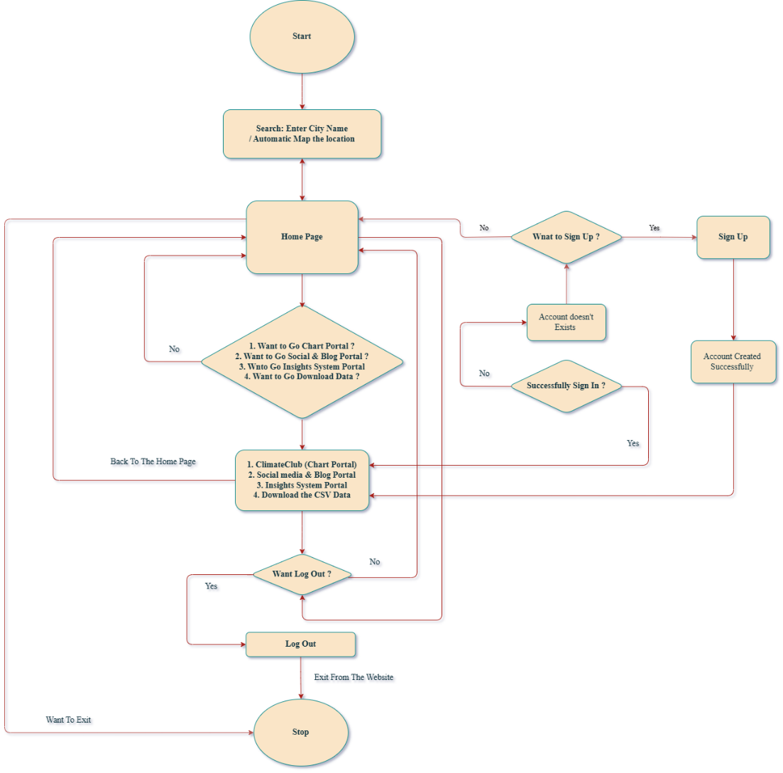

Fig 4.1 : Flow Chart: Workflow of web application

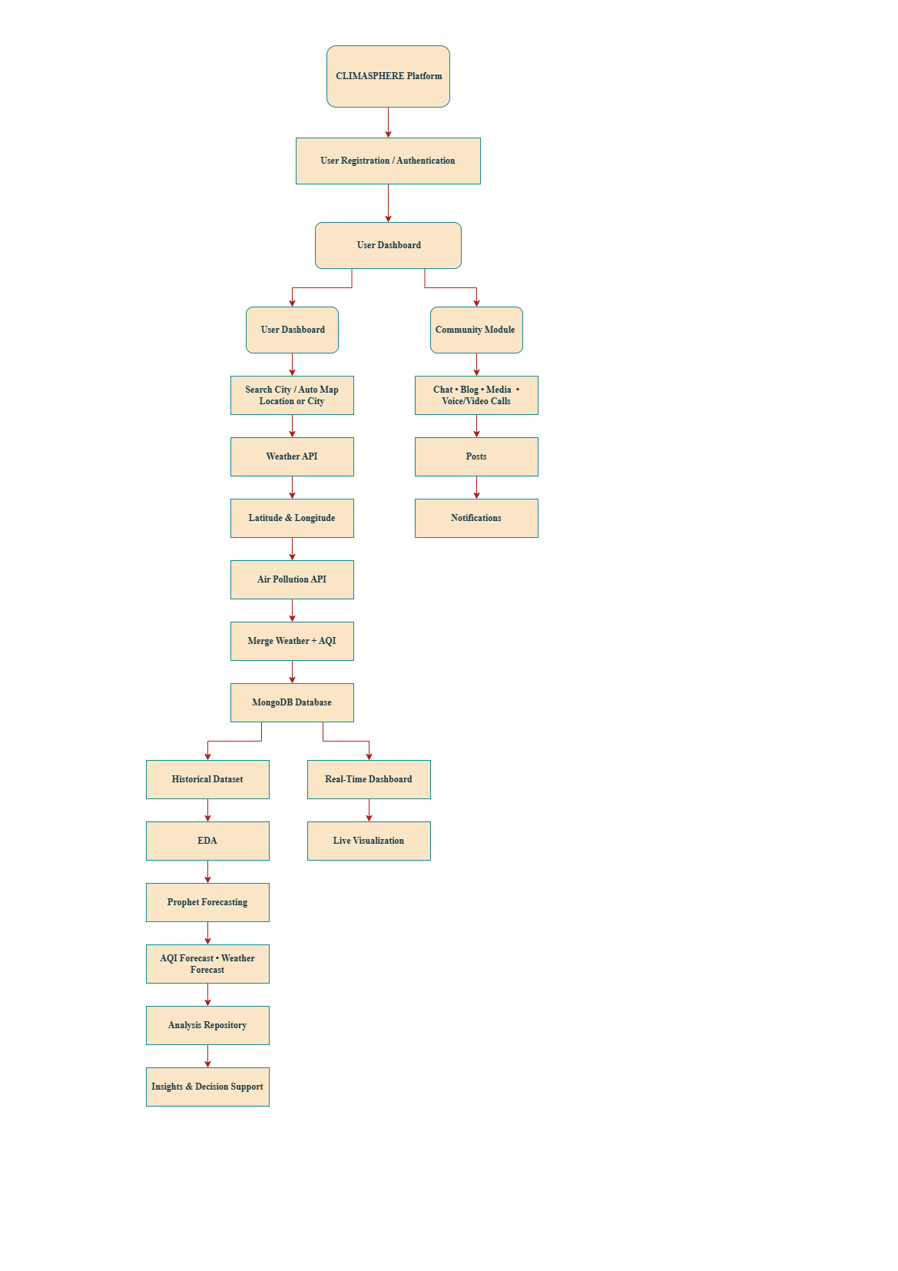
4.2 System Development Methodology

Fig 4.2: Flow Chart: System Development

Step 1: User Authentication and Access: The workflow begins when users access the ClimaSphere web application. Basic environmental information is available without authentication, whereas features such as saved locations, historical records, downloadable datasets, collaboration, chat, social interactions, and the Analysis & Insights Repository require secure user registration and login. Authentication is implemented using JWT (JSON Web Token) to ensure secure access and role-based authorization.
Step 2: Environmental Data Acquisition: Users search for a location or allow automatic location detection. The backend retrieves real-time weather information using the OpenWeather Weather API and subsequently uses the returned geographical coordinates to fetch corresponding air pollution data through the OpenWeather Air Pollution API.
Step 3: Data Processing and Storage: The retrieved weather and air pollution data are validated, merged into a unified dataset, and stored in MongoDB. This centralized database supports efficient retrieval of real-time and historical records while enabling analysis, forecasting, and personalized user services.
Step 4: Real-Time Visualization: The processed data is displayed through an interactive dashboard developed using React.js. Weather conditions, AQI, pollutant concentrations, and other environmental parameters are presented using charts, graphs, maps, and summary cards for easy interpretation.
Step 5: Historical Data Management: Historical environmental datasets collected from multiple Indian cities are maintained for long-term analysis, trend identification, and forecasting. Users can also download datasets in CSV format for research and academic purposes.
Step 6: Exploratory Data Analysis (EDA): Historical datasets are analysed using Python libraries such as NumPy, Pandas, Matplotlib, and Seaborn. Data preprocessing, statistical analysis, and visualization are performed to identify environmental trends, seasonal variations, pollutant relationships, and other meaningful insights.
Step 7: Forecasting and Predictive Analysis: The processed historical datasets are used to generate AQI forecasts using the Prophet model, while the application also provides hourly and multi-day weather forecasts. The results are presented through interactive visualizations to help users anticipate future environmental conditions.
Step 8: Analysis and Insights Repository: Authenticated analysts, researchers, scientists, engineers, and authorized contributors can publish analytical findings, research reports, and environmental observations through the Analysis & Insights Repository, promoting knowledge sharing and public awareness.
Step 9: Community Collaboration: The platform supports user interaction through community discussions, messaging, voice and video calling, media sharing, blogging, and social posts. These features encourage collaboration among researchers, environmental professionals, students, and the general public.
Step 10: Notifications and Decision Support: The system delivers weather alerts, AQI notifications, chat notifications, and other important updates to users. By combining monitoring, analysis, forecasting, visualization, and collaboration, ClimaSphere supports environmental awareness and enables informed, data-driven decision-making.

4.4 System Architecture
The proposed ClimaSphere system follows a modular client-server architecture developed using the MERN (MongoDB, Express.js, React.js, and Node.js) technology stack. The major architectural components are described below.

1. Presentation Layer (Frontend): The presentation layer is developed using React.js and Tailwind CSS, providing a responsive and interactive user interface. It enables users to access weather information, air quality data, dashboards, community features, and personalized services.
2. Application Layer (Backend): The backend is developed using Node.js and Express.js, which handle business logic, user authentication, API communication, data processing, and interaction with the database.
3. Environmental Data Layer: Real-time weather information and air pollution data are collected through the OpenWeather Weather API and OpenWeather Air Pollution API. The backend processes and combines the API responses before making them available to users.
4. Database Layer: MongoDB stores user profiles, authentication data, historical environmental records, chat messages, blog posts, notifications, saved locations, and other application data, ensuring secure and efficient data management.
5. Analytics & Forecasting Layer: Historical environmental datasets are analyzed through a separate Python-based Streamlit platform, where Exploratory Data Analysis (EDA) and Prophet-based forecasting are performed. The analytical results are presented through interactive visualizations and forecasting dashboards.
6. Collaboration Layer: This layer includes the Analysis & Insights Repository, Chat System, Voice/Video Calling, Media Sharing, Social Media & Blog, and Notification System, enabling collaboration and communication among users, researchers, and environmental analysts.
7. Overall System Integration: All architectural components work together to provide a unified environmental intelligence platform. The modular architecture improves scalability, maintainability, flexibility, and system performance while allowing independent development and future expansion of each module.

4.5 Data Collection Method
The ClimaSphere platform utilizes both real-time environmental data and historical environmental datasets to support monitoring, analysis, and forecasting. Data collection is performed through authenticated APIs and publicly available environmental sources.

1. Real-Time Weather Data Collection: Real-time weather information is collected using the OpenWeather Weather API. Users can search for any supported city worldwide, and the API returns live weather parameters such as temperature, humidity, atmospheric pressure, wind speed, wind direction, cloud coverage, visibility, sunrise and sunset time, and current weather conditions.
2. Real-Time Air Pollution Data Collection: The geographical coordinates (latitude and longitude) obtained from the weather API response are used to request air quality information from the OpenWeather Air Pollution API. The API provides the Air Quality Index (AQI) along with pollutant concentrations including PM2.5, PM10, CO, NO₂, SO₂, O₃, and NH₃, enabling environmental monitoring.
3. Historical Dataset Collection: Historical weather and air pollution datasets are collected, organized, and maintained for selected Indian cities. These datasets serve as the foundation for Exploratory Data Analysis (EDA), statistical analysis, environmental trend identification, and Prophet-based forecasting.
4. User-Generated Data Collection: Apart from environmental data, the system collects user-generated information such as account details, saved locations, blog posts, analysis reports, chat messages, media files, and notifications. These records are securely stored in MongoDB to support personalized services and collaborative features.
5. Data Validation and Storage: Before storage, the collected data undergoes basic validation to ensure completeness and consistency. The processed information is then stored in the MongoDB database, allowing efficient retrieval for real-time monitoring, historical analysis, and application services.

4.6 Data Collection Tools

Tool / Technology | Purpose
OpenWeather Weather API | Collects real-time weather information such as temperature, humidity, pressure, wind speed, cloud coverage, and weather conditions.
OpenWeather Air Pollution API | Retrieves Air Quality Index (AQI) and pollutant concentrations including PM2.5, PM10, CO, NO₂, SO₂, O₃, and NH₃.
REST API | Facilitates secure communication between the frontend, backend, and external services for data exchange.
MongoDB | Stores user information, environmental records, historical datasets, chat messages, posts, notifications, and application data.
Postman | Used for testing, validating, and debugging API requests and responses during development.
Python | Processes historical datasets for data cleaning, preprocessing, and analytical operations.
Jupyter Notebook | Provides an interactive environment for performing Exploratory Data Analysis (EDA) and forecasting experiments.

4.7 Development & Analytical Tools Used
4.7.1 Development Tools & Technologies

Tool / Technology | Purpose
React.js | Develops the interactive and responsive frontend user interface.
Node.js | Executes backend server-side applications and manages asynchronous operations.
Express.js | Builds RESTful APIs and manages backend routing and middleware.
MongoDB | Stores user information, environmental data, chat messages, posts, and historical datasets.
Tailwind CSS | Designs responsive and modern user interfaces.
Socket.IO | Enables real-time communication for chat and notifications.
JWT | Provides secure user authentication and authorization.
Cloudinary | Stores and manages uploaded images and media files.
Visual Studio Code | Primary Integrated Development Environment (IDE) used for coding.
Git & GitHub | Version control and source code management.
Postman | Tests and validates backend APIs during development.

4.7.2 Analytical Tools & Technologies

Tool / Technology | Purpose
Python | Performs data processing, analysis, and forecasting.
Jupyter Notebook | Interactive environment for data analysis and experimentation.
Pandas | Data cleaning, preprocessing, and manipulation.
NumPy | Numerical computations and array operations.
Matplotlib | Generates statistical and analytical visualizations.
Seaborn | Creates advanced statistical graphs and distribution plots.
Plotly | Develops charts and forecasting visualizations for the Streamlit app.
Scikit-learn | Builds and evaluates machine learning models, including the Random Forest Regressor for AQI prediction.
Joblib | Saves and loads trained machine learning models for efficient reuse during prediction.
Prophet | Performs weather and AQI forecasting based on historical datasets.
Chart.js | Displays interactive charts and graphs within the web application.
Streamlit | Deploys the analytical dashboard for EDA and forecasting.

4.8 Functional Module Design
The ClimaSphere platform follows a modular software architecture, where each module is designed to perform a specific functionality while interacting seamlessly with other components of the system. This modular approach improves scalability, maintainability, and flexibility by allowing independent development and future enhancement of individual modules.

1. User Management Module: Manages user registration, authentication, authorization, profile management, and saved locations. It ensures secure access to personalized services using JWT-based authentication.
2. Environmental Monitoring Module: Retrieves real-time weather and air pollution information using the OpenWeather Weather API and Air Pollution API. The module displays weather conditions, AQI, pollutant concentrations, and other environmental parameters.
3. Dashboard & Visualization Module: Provides interactive dashboards, charts, summary cards, and graphical representations of environmental information, enabling users to understand current weather and pollution conditions effectively.
4. Historical Data Management Module: Maintains historical environmental datasets and allows users to access and download previous weather and air quality records for further analysis and research.
5. Forecasting Module: Provides weather behaviour forecasting and AQI trend forecasting using a dedicated Python-based Streamlit application powered by the Prophet time-series forecasting model. The module visualizes forecast results through interactive charts.
6. Analysis & Insights Repository: Allows verified analysts, researchers, scientists, and authorized contributors to publish environmental analyses, research findings, and data-driven insights, promoting knowledge sharing and environmental awareness.
7. Community Collaboration Module: Facilitates user interaction through single chat, group chat, voice/video calling, media sharing, blogging, and social posts, encouraging communication and collaborative learning.
8. Notification & Alert Module: Provides weather alerts, AQI notifications, chat updates, and important system notifications, ensuring users remain informed about environmental conditions and platform activities.
9. Data Download Module: Allows authenticated users to download historical weather and pollution datasets in CSV format for offline analysis, research, and academic purposes.
10. Multi-Language & Responsive Interface Module: Supports multiple languages, including English, Hindi, and Bengali, while providing a responsive user interface optimized for desktop, tablet, and mobile devices.

4.9 Use Case Diagram:
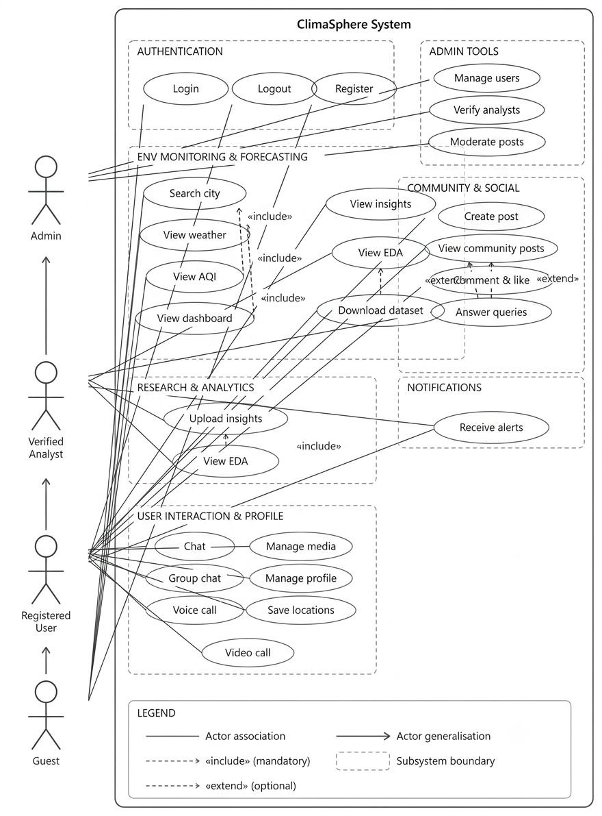

CHAPTER - 5: Data Analysis & Interpretation

5.1 Introduction

This chapter presents the data analysis, interpretation, and statistical findings obtained from the weather and air pollution datasets used in the ClimaSphere platform. The collected environmental data were analyzed using various exploratory data analysis (EDA) techniques to understand weather behaviour, air quality patterns, pollutant distribution, and the relationship between different environmental parameters. The analysis was performed using Python-based analytical tools, and the results are presented through tables, charts, graphs, and statistical visualizations for better understanding and interpretation. This chapter is organized into different analytical sections, including Weather Analysis, Pollution Analysis, AQI vs. Pollution Analysis, Forecasting Analysis, and Dashboard & Web Application Analysis. Each section presents visual representations of the analyzed data along with their descriptions, key insights, and conclusions, enabling readers to understand the observed environmental trends and their practical implications. Furthermore, the forecasting results generated using the Prophet time-series model demonstrate future weather behaviour and Air Quality Index (AQI) trends based on historical datasets. Screenshots of the developed web application are also included to illustrate the practical implementation of various functional modules, providing a comprehensive overview of the analytical capabilities and real-world applicability of the proposed ClimaSphere platform.

5.2 Exploratory Data Analysis (EDA)
5.2.1 Dataset Description: The dataset used in this project contains weather and air pollution observations recorded as individual records, not aggregated daily values. Each record represents a valid observation captured at a specific time and location.

5.2.2 Main Components:
- Data Type: Time-series environmental records
- Granularity: Day-Level
- Geographical Scope: Multiple Indian cities
- Temporal Nature: Sequential time-stamped data

5.2.3 Important Columns (The dataset includes, but is not limited to):
- City
- Timestamp / Date-Time
- Weather parameters (temperature, wind speed, humidity, visibilty etc.)
- Pollutant concentrations (PM2.5, PM10, NO₂, SO₂, CO)
- Derived AQI and AQI category columns (created during analysis)
5.2.4 Initial Data Exploration (The dataset was first loaded and inspected to understand):
  - Column names
  - Data types
  - Number of records
  - Presence of missing or duplicate values
  - Basic statistical summaries were generated to observe distributions and ranges.

5.2.5 Missing Value Analysis (Examined both numerically and visually):
- Quantifying missing values for each column.
- Visualizing missingness patterns to understand whether values were randomly missing or systematically absent.
- Identifying columns requiring special handling due to time-series dependency.

5.2.6 Duplicate Record Handling: The dataset was checked for duplicate entries. Any duplicated records were removed to ensure data integrity and prevent biased analysis.

5.2.7 Data Cleaning and Preprocessing: Since the dataset is time-series in nature, special attention was given to time-dependent variables.

A) Wind Speed Handling:
- Missing values in wind-related variables were handled using time-based interpolation.
- Interpolation was selected because it preserves temporal continuity and avoids artificial jumps in values.
- This approach ensured that meteorological trends remained consistent across time.

B) Wind Direction Handling:
- Missing wind direction values were handled using time-based interpolation, leveraging the temporal continuity of meteorological data.
- Interpolation was chosen instead of mean or median imputation to preserve natural directional transitions over time.
- This approach prevents abrupt or unrealistic changes in wind direction that could distort dispersion-related interpretations.

C) Nitric Oxide (NO) Handling:
- NO concentration values were converted to numeric format to eliminate non-numeric entries.
- Invalid or missing values were retained as null (NaN) where appropriate, rather than interpolated.
- NO was not used directly in AQI calculation, in accordance with CPCB AQI standards, but was retained for exploratory and correlation analysis.
D) Ammonia (NH₃) Handling:
- NH₃ values were converted to numeric format to ensure computational consistency.
- Missing NH₃ values were retained as NaN where data was unavailable.
- NH₃ values were included in AQI sub-index computation only when valid data was present.

5.2.8 Data Type Standardization:
- Pollutant concentration columns were converted to numeric format.
- Invalid or non-numeric entries were safely coerced to missing values.
- Column names were standardized for consistency across AQI computation steps.

5.2.9 Feature Engineering (AQI Categorization):
Since we have AQI values, they were categorized into qualitative AQI levels such as Good, Satisfactory, Moderate, Poor, Very Poor, and Severe. This categorization enabled: Easier interpretation of air quality conditions, Categorical comparisons across cities, Top cities that suffer for low to high AQI.

5.2.10 Distribution Analysis:
- Univariate distributions of AQI and pollutant concentrations were analysed.
- Histograms and density plots were used to identify skewness and extreme values.
- This helped in understanding the overall pollution severity spread.

5.2.11 City-Wise AQI Analysis:
- AQI records were grouped by city to study spatial variation.
- Both frequency and proportion-based metrics were explored.

5.2.12 Bias Handling:
- Cities with extremely low record counts were excluded using a minimum threshold.
- This avoided small-sample bias, where cities with very few records could misleadingly show extreme proportions.
- This correction ensured fair and statistically meaningful comparisons across cities.

5.2.13 Visualization Strategy
Bar charts and comparative plots were used to visualize:
  - AQI category distributions
  - AQI relationship with different factors.
  - City-wise pollution severity
  - Relative contribution of high-pollution records
  - Clear labeling and filtering criteria were applied to maintain interpretability.

5.3 EDA Screenshot with Insights Information & Conclusion:
5.3.1 Weather Analysis:

Visualizations | Information
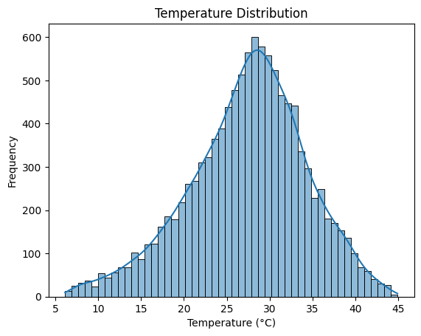  Fig 5.3.1 A | Chart Type: Histogram with Kernel Density Estimation (KDE)  Description: The chart shows the distribution of temperature values (°C) across the dataset, indicating how frequently different temperature ranges occur.  Key Insights:  Most temperature values are concentrated between 24°C and 34°C.  The highest frequency occurs around 29°C–30°C, representing the most common temperature range.  Very low (<10°C) and very high (>40°C) temperatures occur rarely.  The smooth bell-shaped distribution indicates a consistent temperature pattern.  Conclusion: Overall, the temperature distribution reflects predominantly warm climatic conditions with stable temperature variations, making temperature a key factor in weather and air quality analysis.
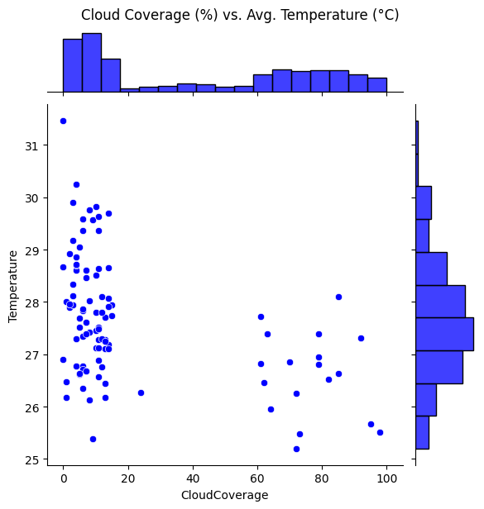  Fig 5.3.1 B | Chart Type: Scatter plot with marginal histograms  Description: The chart illustrates the relationship between cloud coverage (%) and average temperature (°C), with marginal histograms showing the distribution of both variables.  Key Insights:  Most observations are concentrated at low cloud coverage (0–15%).  Higher cloud coverage (60–100%) is associated with slightly lower temperatures.  Temperatures remain mostly between 26°C and 29°C across all cloud coverage levels.  The scatter indicates a weak negative relationship between cloud coverage and average temperature.  Conclusion: Overall, the chart suggests that increasing cloud coverage is associated with a slight decrease in temperature, although the relationship is not strong. Temperature remains relatively stable despite variations in cloud coverage.
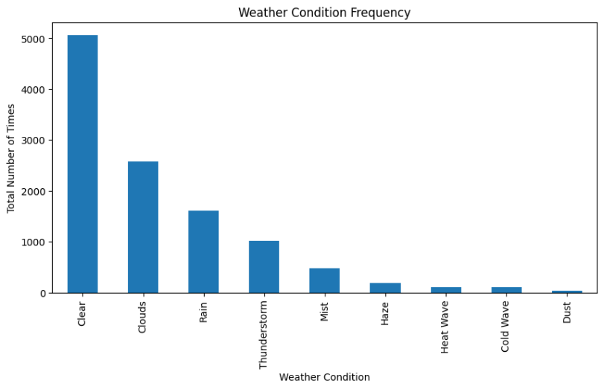  Fig 5.3.1 C | Chart Type: Bar chart  Description: The chart displays the frequency of different weather conditions recorded in the dataset, showing how often each weather condition occurs.  Key Insights:  Clear weather is the most frequently observed condition, with over 5,000 occurrences.  Clouds and Rain are the second and third most common weather conditions, respectively.  Thunderstorms and Mist occur less frequently than the major weather conditions.  Haze, Heat Wave, Cold Wave, and Dust are relatively rare, with the lowest recorded frequencies.  Conclusion: Overall, the dataset is dominated by clear and cloudy weather conditions, while extreme weather events occur infrequently. This distribution indicates that normal weather conditions are more prevalent than severe or uncommon weather events during the study period.
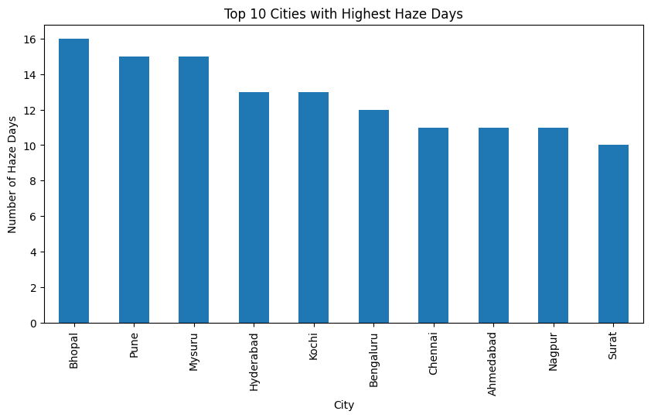  Fig 5.3.1 D | Chart Type: Bar chart  Description: The chart presents the top 10 cities with the highest number of haze days recorded in the dataset, highlighting the cities most frequently affected by haze conditions.  Key Insights:  Bhopal recorded the highest number of haze days (16), making it the most affected city.  Pune and Mysuru followed closely with 15 haze days each.  Hyderabad and Kochi each experienced 13 haze days.  Surat recorded the lowest number of haze days (10) among the top 10 cities.  Conclusion: Overall, the chart indicates that haze occurrences are concentrated in a few cities, with Bhopal, Pune, and Mysuru experiencing the highest frequency. This information is valuable for identifying regions that may require greater attention to air quality monitoring and pollution control measures.
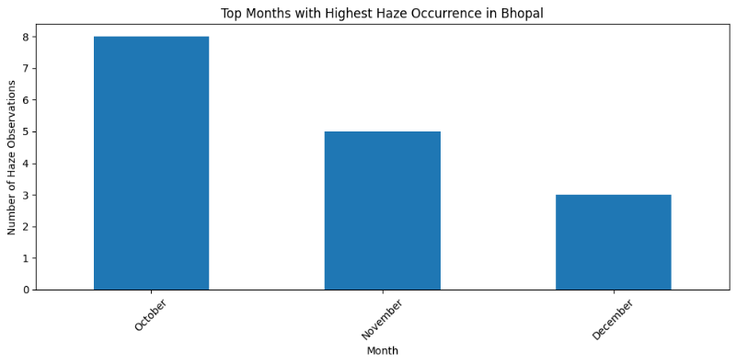  Fig 5.3.1 E | Chart Type: Bar chart  Description: The chart shows the months with the highest haze occurrence in Bhopal, indicating the number of haze observations recorded during each month.  Key Insights:  October recorded the highest number of haze observations (8).  November followed with 5 haze observations.  December had the lowest haze occurrence (3) among the displayed months.  Haze occurrences show a decreasing trend from October to December.  Conclusion: Overall, the chart indicates that haze events in Bhopal were most frequent during October and gradually declined in the following months. This seasonal trend can assist in planning air quality monitoring and pollution control measures during high-risk periods.
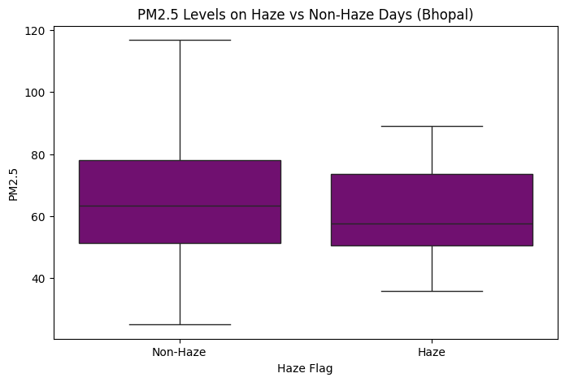  Fig 5.3.1 F | Chart Type: Box plot  Description: The chart compares the distribution of PM2.5 levels on Haze and Non-Haze days in Bhopal, highlighting differences in central tendency and variability.  Key Insights:  Non-Haze days show a slightly higher median PM2.5 level than Haze days.  PM2.5 levels on Non-Haze days have a wider distribution, indicating greater variability.  Haze days exhibit a more consistent range of PM2.5 values with fewer extreme observations.  Both Haze and Non-Haze days have overlapping PM2.5 ranges, suggesting similar pollution levels during many observations.  Conclusion: Overall, the chart indicates that PM2.5 concentrations vary under both Haze and Non-Haze conditions, with Non-Haze days showing greater fluctuations. This suggests that PM2.5 levels alone may not fully explain haze occurrences, and other meteorological or environmental factors may also contribute.
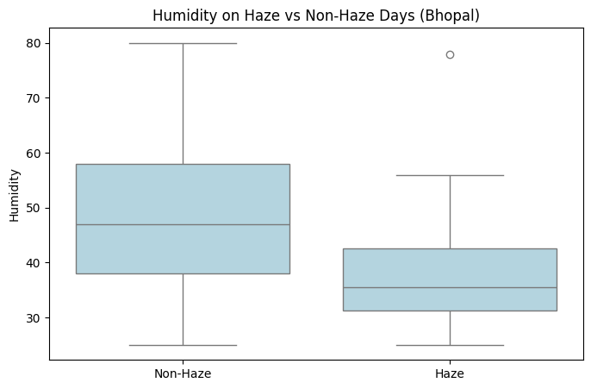  Fig 5.3.1 G | Chart Type: Box plot  Description: The chart compares the distribution of humidity levels on Haze and Non-Haze days in Bhopal, highlighting differences in median values and variability.  Key Insights:  Non-Haze days have a higher median humidity than Haze days.  Humidity on Non-Haze days shows greater variability, with a wider range of values.  Haze days are generally associated with lower humidity levels.  A high humidity outlier is observed on Haze days, indicating an unusual weather event.  Conclusion: Overall, the chart suggests that Non-Haze days tend to experience higher and more variable humidity, while Haze days generally occur under lower humidity conditions. The presence of an outlier indicates that humidity alone may not fully determine haze formation.
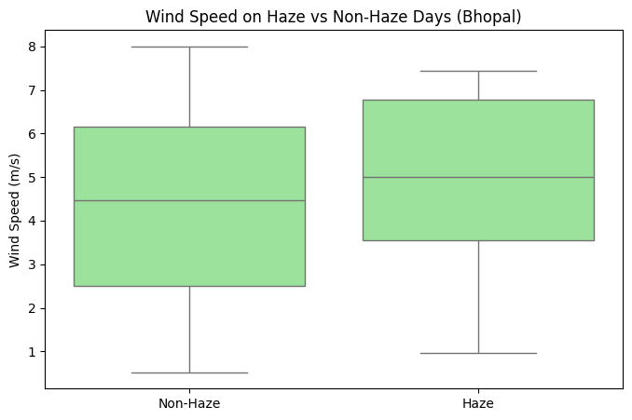  Fig 5.3.1 H | Chart Type: Box plot  Description: The chart compares the distribution of wind speed (m/s) on Haze and Non-Haze days in Bhopal, highlighting differences in median values and variability.  Key Insights:  Haze days have a slightly higher median wind speed than Non-Haze days.  Wind speed on Non-Haze days shows greater variability, with a wider overall range.  Haze days exhibit a more consistent distribution of wind speeds.  The wind speed ranges for both Haze and Non-Haze days overlap considerably.  Conclusion: Overall, the chart indicates that wind speed is slightly higher on Haze days, but the substantial overlap between the two distributions suggests that wind speed alone is not a determining factor for haze occurrence. Other meteorological and environmental conditions are also likely to influence haze formation.
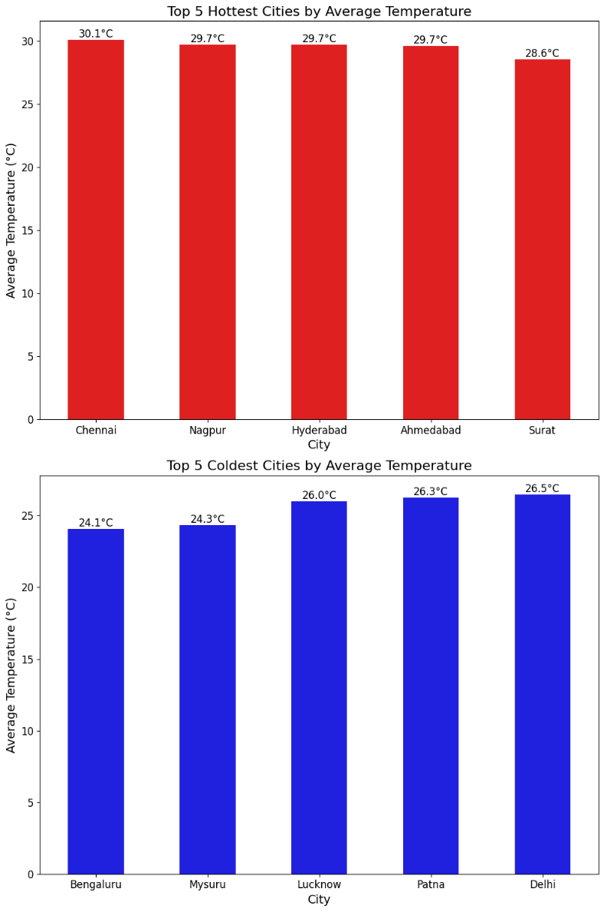  Fig 5.3.1 I | Visualization 1: Top 5 Hottest Cities by Avg. Temperature  Chart Type: Bar Chart  Description: The chart displays the top five cities with the highest average temperatures recorded in the dataset.  Key Insights:  Chennai recorded the highest average temperature (30.1°C).  Nagpur, Hyderabad, and Ahmedabad each recorded an average temperature of 29.7°C.  Surat ranked fifth with an average temperature of 28.6°C.  The temperature difference among the top five hottest cities is relatively small.  Conclusion: Overall, the chart indicates that Chennai is the hottest city in the dataset, while the other top cities also experience consistently high average temperatures, reflecting warm climatic conditions.  Visualization 2: Top 5 Coldest Cities by Avg. Temperature  Chart Type: Bar Chart  Description: The chart presents the five cities with the lowest average temperatures recorded in the dataset.  Key Insights:  Bengaluru recorded the lowest average temperature (24.1°C).  Mysuru followed closely with an average temperature of 24.3°C.  Lucknow, Patna, and Delhi recorded average temperatures between 26.0°C and 26.5°C.  The variation in average temperature among the coldest cities is relatively small.  Conclusion: Overall, the chart shows that Bengaluru experienced the lowest average temperature in the dataset, while the remaining cities also maintained comparatively cooler climatic conditions.
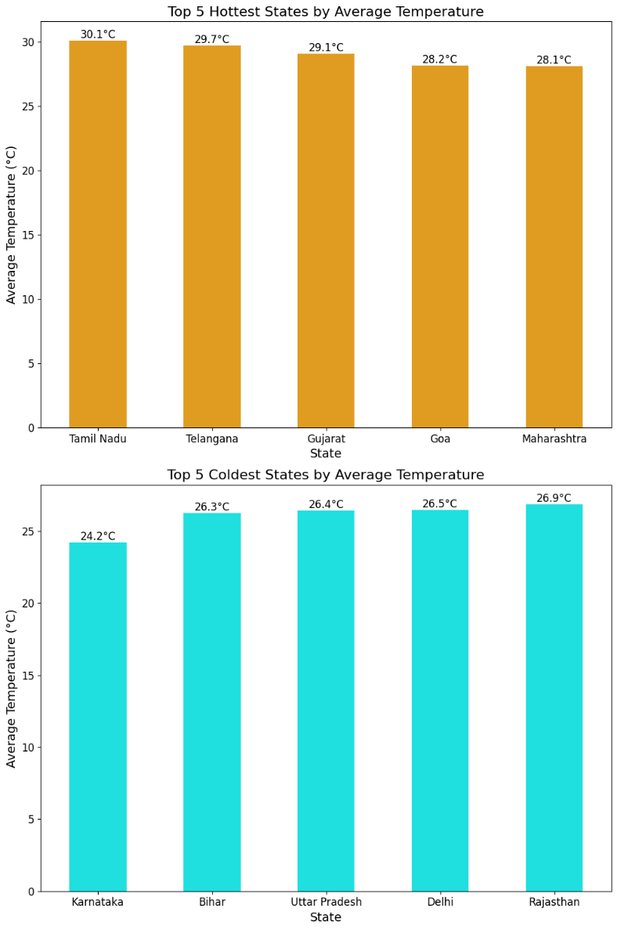  Fig 5.3.1 J | Visualization 1: Top 5 Hottest States by Avg. Temperature  Chart Type: Bar Chart  Description: The chart displays the top five states with the highest average temperatures recorded in the dataset.  Key Insights:  Tamil Nadu recorded the highest average temperature (30.1°C).  Telangana ranked second with an average temperature of 29.7°C.  Gujarat, Goa, and Maharashtra also recorded high average temperatures above 28°C.  The temperature difference among the top five hottest states is relatively small.  Conclusion: Overall, the chart indicates that Tamil Nadu is the hottest state in the dataset, while the other top-ranked states also experience consistently warm climatic conditions.  Visualization 2: Top 5 Coldest States by Avg. Temperature  Chart Type: Bar Chart  Description: The chart presents the five states with the lowest average temperatures recorded in the dataset.  Key Insights:  Karnataka recorded the lowest average temperature (24.2°C).  Bihar, Uttar Pradesh, and Delhi had average temperatures between 26.3°C and 26.5°C.  Rajasthan ranked fifth with an average temperature of 26.9°C.  The variation in average temperature among the coldest states is relatively small.  Conclusion: Overall, the chart shows that Karnataka experienced the lowest average temperature in the dataset, while the remaining states also maintained comparatively cooler climatic conditions.

5.3.2 Pollution Analysis:

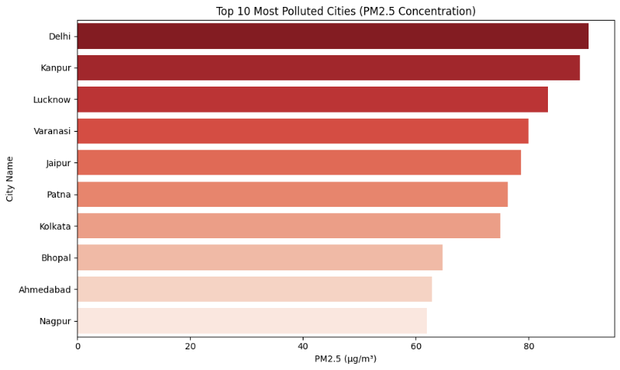  Fig 5.3.2 A | Chart Type: Horizontal bar chart  Description: The chart displays the top 10 most polluted cities based on their average PM2.5 concentration (µg/m³), highlighting cities with the highest particulate matter levels.  Key Insights:  - Delhi recorded the highest PM2.5 concentration, making it the most polluted city in the dataset.  - Kanpur and Lucknow ranked second and third, respectively, with consistently high PM2.5 levels.  - Varanasi, Jaipur, Patna, and Kolkata also recorded elevated PM2.5 concentrations.  - Nagpur recorded the lowest PM2.5 concentration among the top 10 most polluted cities.  Conclusion: Overall, the chart indicates that Delhi, Kanpur, and Lucknow experience the highest PM2.5 pollution levels. These findings highlight the need for targeted air quality management and pollution control measures in the most affected urban areas.
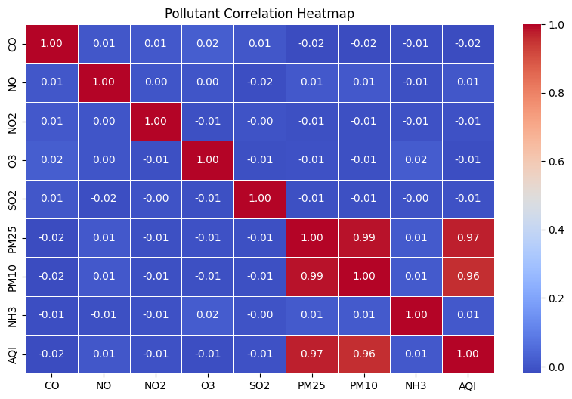  Fig 5.3.2 B | Chart Type: Correlation heatmap  Description: The heatmap shows the correlation between major air pollutants and the Air Quality Index (AQI), indicating the strength of their linear relationships.  Key Insights:  - PM2.5 and PM10 show a very strong positive correlation (0.99).  - AQI has a strong positive correlation with PM2.5 (0.97) and PM10 (0.96).  - CO, NO, NO₂, O₃, SO₂, and NH₃ exhibit negligible correlations with AQI and with each other.  - Particulate pollutants (PM2.5 and PM10) have the strongest association with air quality in the dataset.  Conclusion: Overall, the heatmap indicates that PM2.5 and PM10 are the pollutants most strongly associated with AQI, whereas the remaining pollutants show minimal linear relationships. This highlights the importance of monitoring particulate matter for effective air quality assessment.
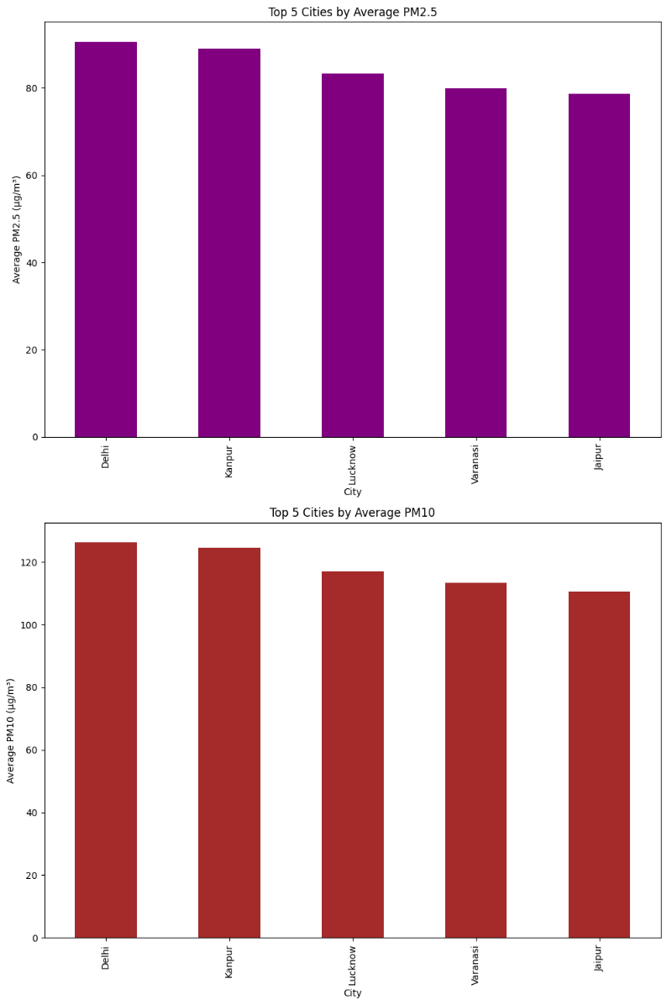  Fig 5.3.2 C | Visualization 1: Top 5 Cities by Average PM2.5  Chart Type: Bar Chart  Description: The chart displays the top five cities with the highest average PM2.5 concentrations recorded in the dataset.  Key Insights:  - Delhi recorded the highest average PM2.5 concentration.  - Kanpur ranked second with a PM2.5 level close to Delhi.  - Lucknow, Varanasi, and Jaipur also recorded consistently high PM2.5 concentrations.  - The difference in PM2.5 levels among the top five cities is relatively small.  Conclusion: Overall, the chart indicates that Delhi and Kanpur experience the highest average PM2.5 concentrations, highlighting them as cities with greater exposure to fine particulate pollution.  Visualization 2: Top 5 Cities by Average PM10  Chart Type: Bar Chart  Description: The chart presents the top five cities with the highest average PM10 concentrations recorded in the dataset.  Key Insights:  - Delhi recorded the highest average PM10 concentration.  - Kanpur followed closely with the second-highest PM10 level.  - Lucknow, Varanasi, and Jaipur also exhibited elevated PM10 concentrations.  - PM10 concentrations show a gradual decline from Delhi to Jaipur.  Conclusion: Overall, the chart shows that Delhi and Kanpur have the highest average PM10 concentrations, indicating a greater presence of coarse particulate matter and emphasizing the need for effective air pollution control measures in these cities.
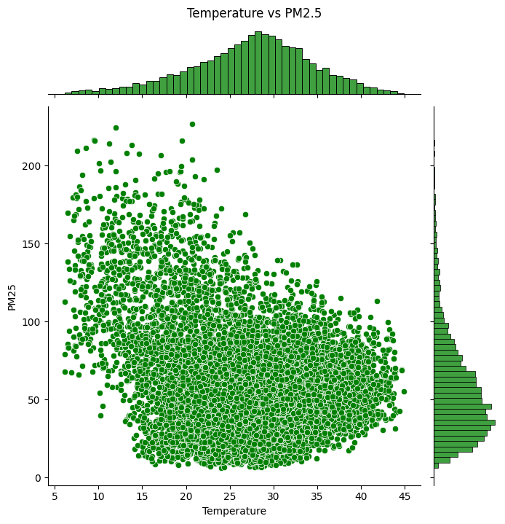  Fig 5.3.2 D | Chart Type: Scatter plot with marginal histograms  Description: The chart illustrates the relationship between temperature (°C) and PM2.5 concentration (µg/m³), with marginal histograms showing the distribution of both variables.  Key Insights:  - PM2.5 concentrations are widely distributed across all temperature ranges.  - Higher PM2.5 values are more frequently observed at lower to moderate temperatures (10°C–25°C).  - At higher temperatures (above 35°C), PM2.5 values are generally lower and less variable.  - The scatter suggests a weak negative relationship between temperature and PM2.5 concentration.  Conclusion: Overall, the chart indicates that PM2.5 concentrations tend to decrease slightly as temperature increases, although the relationship is weak. This suggests that temperature alone does not determine PM2.5 levels, and other environmental factors also influence particulate pollution.
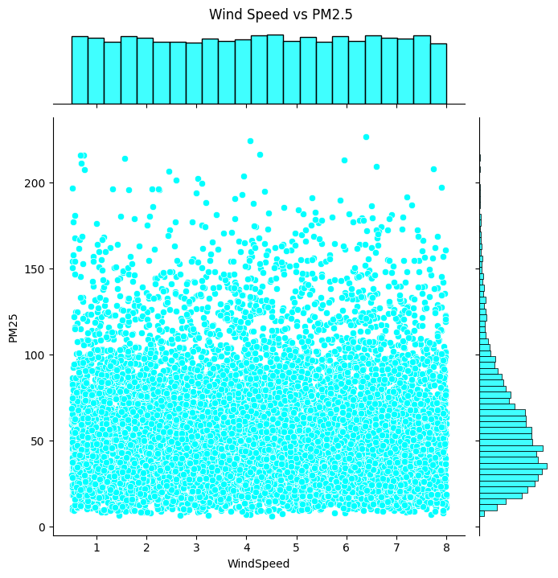  Fig 5.3.2 E | Chart Type: Scatter plot with marginal histograms  Description: This chart illustrates the relationship between wind speed (m/s) and PM2.5 concentration (µg/m³), along with the distribution of both variables.  Key Insights:  - PM2.5 concentrations are distributed across the entire range of wind speeds.  - No clear linear relationship is observed between wind speed and PM2.5 levels.  - Higher PM2.5 values occur at both low and high wind speeds, indicating considerable variability.  - Most PM2.5 observations are concentrated below 100 µg/m³ regardless of wind speed.  Conclusion: Overall, the chart suggests that wind speed has little direct influence on PM2.5 concentration in the dataset. The wide dispersion of data points indicates that additional meteorological and environmental factors contribute to variations in particulate pollution.
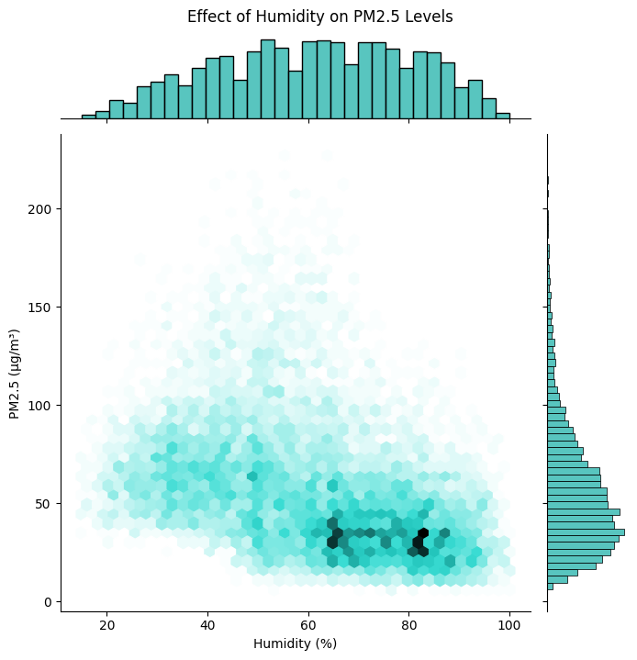  Fig 5.3.2 F | Chart Type: Hexbin plot with marginal histograms  Description: The chart illustrates the relationship between humidity (%) and PM2.5 concentration (µg/m³). The hexagonal bins represent the density of observations, while the marginal histograms show the distribution of humidity and PM2.5 values.  Key Insights:  - The highest concentration of observations occurs at high humidity levels (65%–85%) with PM2.5 values between 20 and 50 µg/m³.  - PM2.5 values exhibit greater variability at moderate humidity levels (40%–60%).  - Higher PM2.5 concentrations are less frequent at very high humidity levels.  - The relationship between humidity and PM2.5 appears to be weak and non-linear.  Conclusion: Overall, the chart suggests that humidity has a limited and non-linear influence on PM2.5 concentrations. While most observations occur under moderate to high humidity with relatively lower PM2.5 levels, other environmental factors are also likely to affect particulate pollution.
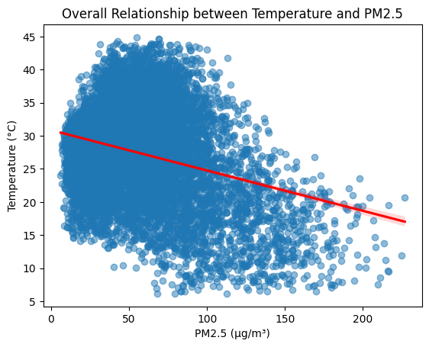  Fig 5.3.2 G | Chart Type: Scatter plot with regression line  Description: This chart illustrates the overall relationship between PM2.5 concentration (µg/m³) and temperature (°C), with a fitted regression line indicating the general trend.  Key Insights:  - The regression line shows a negative relationship between PM2.5 concentration and temperature.  - Higher PM2.5 concentrations are generally associated with lower temperatures.  - Most observations are concentrated between 20–40°C and 20–100 µg/m³ PM2.5.  - The wide spread of data points indicates considerable variability in the relationship.  Conclusion: Overall, the chart suggests a weak negative correlation between temperature and PM2.5 concentration, indicating that PM2.5 levels tend to decrease as temperature increases. However, the large dispersion of observations implies that temperature alone does not fully explain variations in particulate pollution.

5.3.3 AQI vs. Pollution analysis:

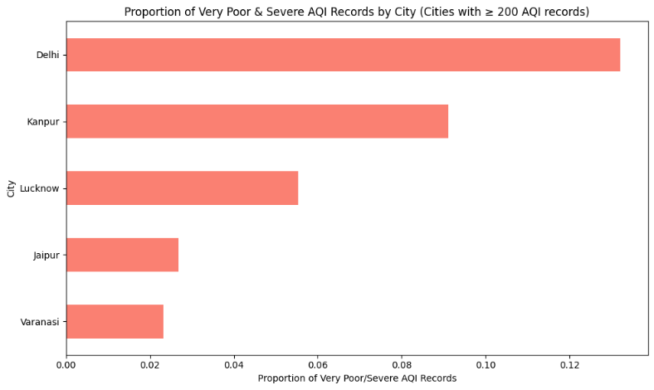  Fig 5.3.3 A | Chart Type: Horizontal Bar Chart  Description: The chart displays the proportion of Very Poor and Severe AQI records for cities with at least 200 AQI observations, highlighting the cities most affected by hazardous air quality.  Key Insights:  - Delhi recorded the highest proportion of Very Poor and Severe AQI records.  - Kanpur ranked second, indicating a substantial share of poor air quality events.  - Lucknow showed a moderate proportion compared to Delhi and Kanpur.  - Jaipur and Varanasi recorded the lowest proportions among the selected cities.  Conclusion: Overall, the chart indicates that Delhi and  Kanpur experience the highest proportion of Very Poor and Severe AQI conditions, highlighting them as the most vulnerable cities to hazardous air pollution within the selected dataset.
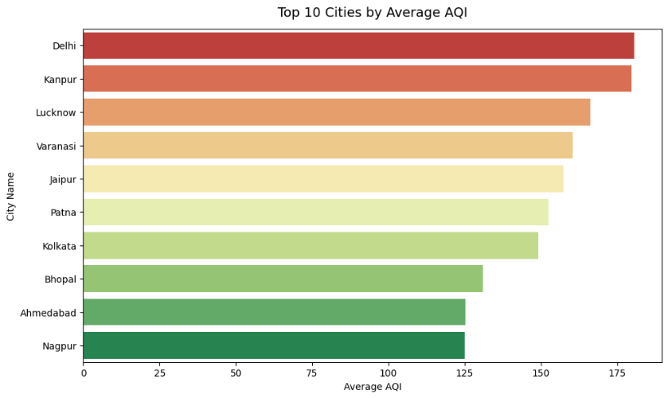  Fig 5.3.3 B | Chart Type: Horizontal Bar Chart  Description: The chart displays the top 10 cities with the highest average AQI, highlighting the cities experiencing the poorest overall air quality.  Key Insights:  - Delhi recorded the highest average AQI among all cities.  - Kanpur ranked second, followed by Lucknow and Varanasi.  - Jaipur, Patna, and Kolkata also recorded consistently high average AQI values.  - Nagpur recorded the lowest average AQI among the top 10 cities.  Conclusion: Overall, the chart indicates that Delhi and Kanpur experience the highest average AQI levels, reflecting poorer air quality compared to the other cities. These findings emphasize the need for targeted air pollution monitoring and mitigation strategies in the most affected urban areas.
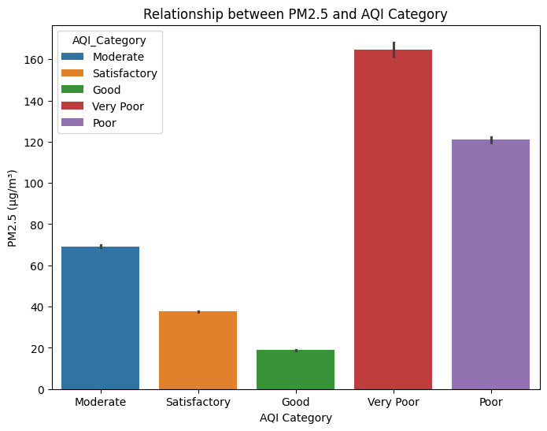  Fig 5.3.3 C | Chart Type: Bar Chart  Description: The chart compares the average PM2.5 concentration (µg/m³) across different AQI categories, illustrating how PM2.5 levels vary with air quality conditions.  Key Insights:  - Very Poor AQI recorded the highest average PM2.5 concentration.  - Poor AQI had the second-highest average PM2.5 level.  - Moderate AQI showed noticeably lower PM2.5 concentrations than the Poor categories.  - Good AQI recorded the lowest average PM2.5 concentration, followed by Satisfactory.  Conclusion: Overall, the chart demonstrates that average PM2.5 concentration increases as AQI worsens, indicating a strong association between particulate matter levels and deteriorating air quality. This highlights PM2.5 as a key indicator for assessing AQI conditions.
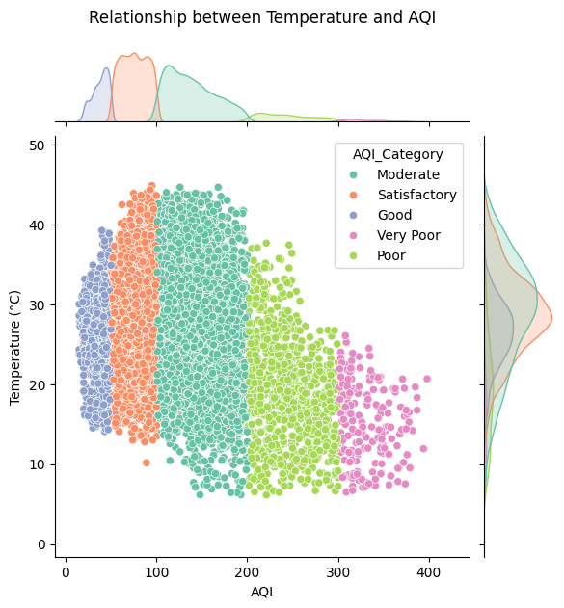  Fig 5.3.3 D | Chart Type: Scatter Plot with Marginal Density Plots  Description: The chart illustrates the relationship between temperature (°C) and AQI across different AQI categories, with marginal density plots showing the distribution of both variables.  Key Insights:  - Good and Satisfactory AQI categories are concentrated at lower AQI values with relatively higher temperatures.  - Poor and Very Poor AQI categories occur at higher AQI values and are generally associated with lower temperatures.  - Moderate AQI records cover the widest range of temperatures and AQI values.  - The distribution suggests a negative relationship between temperature and AQI, where higher AQI levels tend to occur at lower temperatures.  Conclusion: Overall, the chart indicates that AQI tends to increase as temperature decreases, with poorer air quality observed more frequently at lower temperatures. However, the overlap among AQI categories suggests that temperature is only one of several factors influencing air quality.
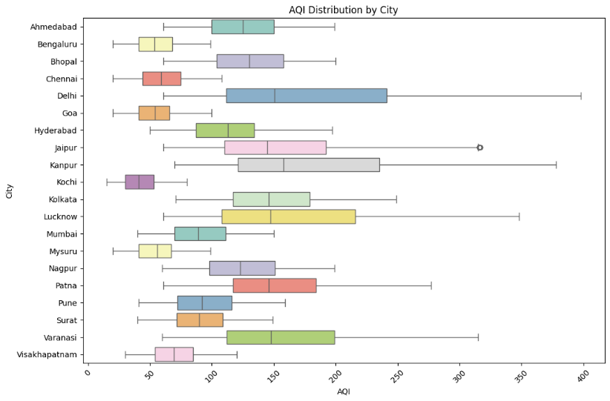  Fig 5.3.3 E | Chart Type: Box Plot  Description: The chart compares the distribution of AQI values across different cities, highlighting variations in median AQI, spread, and overall air quality.  Key Insights:  - Delhi recorded the highest median AQI and the widest distribution, indicating consistently poor air quality.  - Kanpur, Lucknow, and Varanasi also exhibited high AQI values with considerable variability.  - Bengaluru, Kochi, Mysuru, and Goa maintained comparatively lower AQI levels.  - Several cities show wide AQI ranges, indicating significant fluctuations in air quality over time.  Conclusion: Overall, the chart reveals substantial differences in AQI among cities. Delhi, Kanpur, and Lucknow consistently experience poorer air quality, whereas cities such as Bengaluru, Kochi, and Mysuru generally maintain better air quality. The variability across cities highlights the importance of location-specific air pollution monitoring and management.

5.3.4 Pollution Analysis (Line Chart)
Chart Type: Multi-Line Chart
Description: The chart compares the monthly average PM2.5 and PM10 concentrations in Kolkata from January 2025 to July 2026, illustrating how both pollutants vary over time.
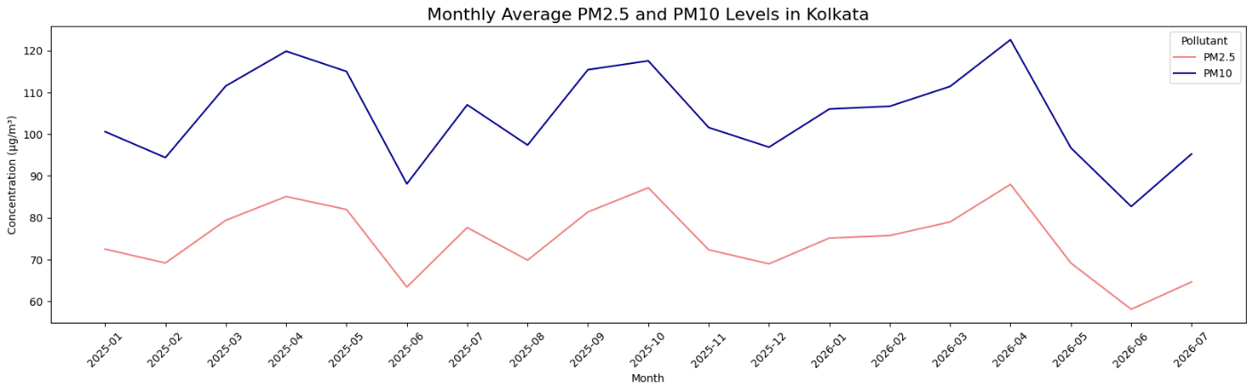

Fig 5.3.4: Monthly Avg. PM2.5 & PM10 Levels in Kolkata
Key Insights:
- PM10 concentrations remain consistently higher than PM2.5 throughout the study period.
- Both PM2.5 and PM10 exhibit similar seasonal trends, with peaks occurring around April and October 2025, and April 2026.
- The highest pollutant levels are observed in April 2026, indicating a period of increased air pollution.
- Both pollutants show noticeable declines during June 2025 and June 2026, suggesting improved air quality during these months.
- The similar movement of both lines indicates a strong positive relationship between PM2.5 and PM10 concentrations over time.
Conclusion: Overall, the chart indicates that PM2.5 and PM10 follow similar monthly patterns, with PM10 consistently recording higher concentrations. The recurring peaks and declines suggest seasonal influences on particulate pollution, highlighting the importance of continuous monitoring for effective air quality management.

5.3.5 Forecasting Analysis

A) Chart Type: Time Series Forecast Plot (Prophet Model)
Description: The chart presents the forecasted AQI trend for Kolkata, comparing historical AQI observations with predicted values over time. The shaded region represents the forecast confidence interval.
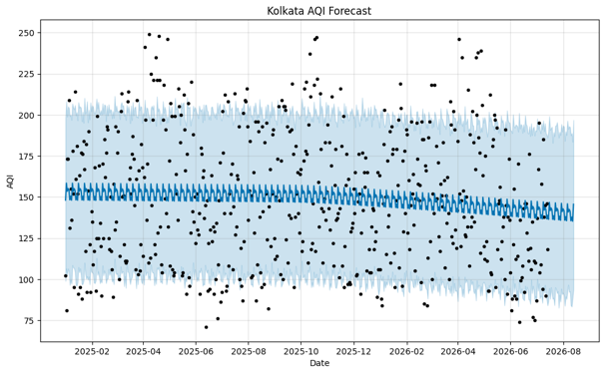

Fig 5.3.5 A: Kolkata AQI Forecast
Key Insights:
- The forecast indicates a gradual decline in AQI levels over the prediction period.
- Regular fluctuations in the forecast suggest the presence of seasonal patterns in AQI.
- Most observed AQI values lie within the forecast confidence interval, indicating a reasonable model fit.
- The wider confidence interval in the forecast period reflects greater uncertainty in long-term AQI predictions.
- Despite the declining trend, the forecast suggests that AQI levels are expected to remain within the moderate air quality range, emphasizing the need for continued monitoring.

Conclusion: Overall, the forecast suggests that Kolkata's AQI is expected to show a slight improvement over time while continuing to exhibit seasonal fluctuations. Although the projected trend is encouraging, the uncertainty in future predictions highlights the importance of continuous air quality monitoring and timely pollution control measures.

B) Chart Type: Time Series Forecast Plot (Prophet Model)
Description: The chart presents the temperature forecast for Ahmedabad generated using the Prophet forecasting model, comparing historical observations with predicted temperatures over time. The shaded region represents the 95% confidence interval of the forecast.
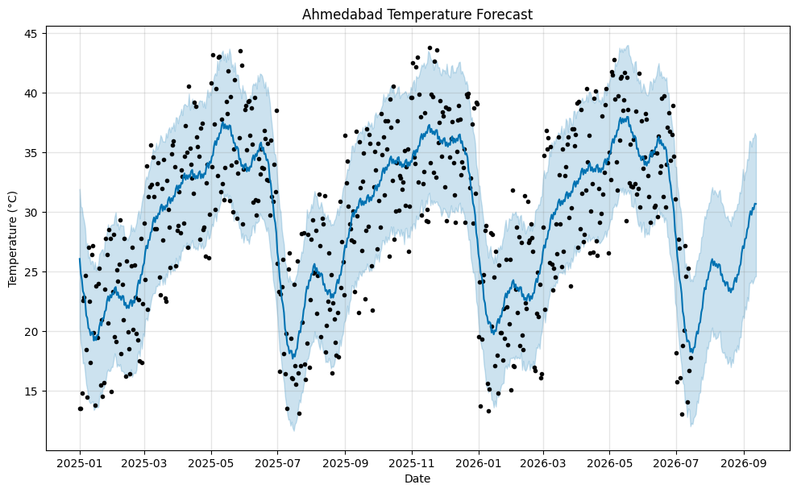

Fig 5.3.5 B: Ahmedabad Temperature Forecast

Key Insights:
- The Prophet model captures clear seasonal temperature patterns, with recurring peaks during summer and lower temperatures during winter.
- Forecasted temperatures generally range between 20°C and 38°C, reflecting Ahmedabad's typical climatic conditions.
- Most historical observations align closely with the forecast trend and fall within the confidence interval.
- The confidence interval widens toward the end of the forecast period, indicating increasing uncertainty in long-term predictions.
- The forecast does not indicate any significant long-term warming or cooling trend, suggesting relatively stable seasonal temperature behaviour.

Conclusion: Overall, the Prophet model forecasts that Ahmedabad's temperature will continue to follow its regular seasonal cycle, with predictable summer peaks and winter declines. The forecast can support weather planning and environmental analysis while acknowledging the uncertainty associated with long-term predictions.

C) Chart Type: Time Series Forecast Plot (Prophet Model)
Description: The chart presents the forecasted temperature trend for Goa using the Prophet forecasting model. The blue line represents the predicted temperature, while the shaded region indicates the 95% confidence interval of the forecast.
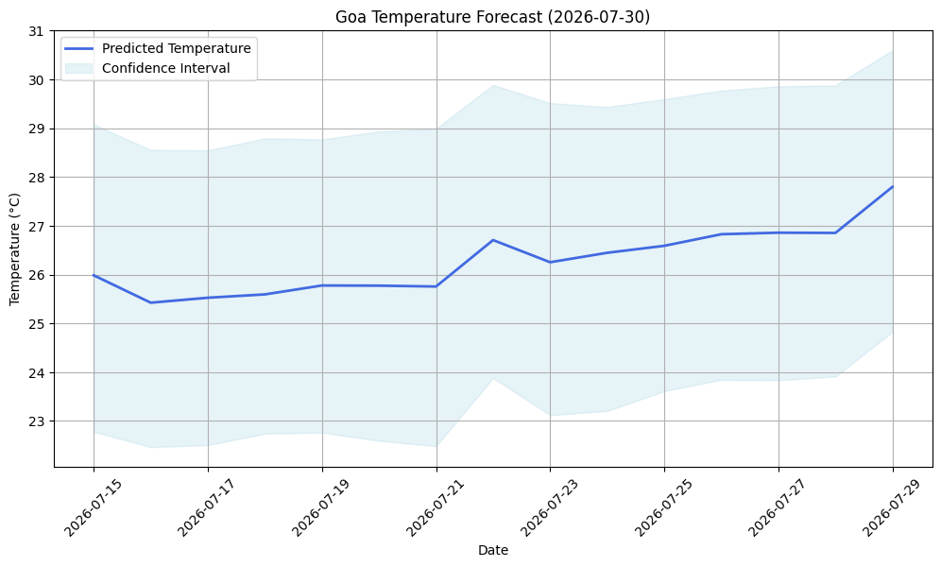

Fig 5.3.5 C: Goa Temperature Forecast (2023-07-30)
Key Insights:
- The forecast indicates a slight upward trend in temperature during the forecast period.
- Predicted temperatures increase gradually from approximately 26°C to 28°C by 29 July 2026.
- The forecast confidence interval remains relatively consistent, indicating a stable level of prediction uncertainty.
- No abrupt fluctuations or extreme temperature changes are predicted during the forecast period.
- The forecast suggests that Goa is expected to maintain warm and stable weather conditions, consistent with its coastal climate.
Conclusion: Overall, the Prophet model predicts a gradual increase in temperature for Goa over the forecast period while maintaining relatively stable weather conditions. The confidence interval reflects the expected uncertainty in the predictions, making the forecast useful for short-term weather planning and environmental analysis.

5.3 Chapter Summary
This chapter presented the data analysis, interpretation, and statistical findings obtained from the weather and air pollution datasets used in the ClimaSphere platform. Various Exploratory Data Analysis (EDA) techniques, statistical visualizations, and forecasting methods were employed to identify weather patterns, air quality trends, pollutant distributions, and relationships among different environmental parameters. The findings obtained from this analysis provide a strong foundation for evaluating the effectiveness of the proposed system, which is further discussed in the next chapter.

CHAPTER - 6: Discussion and Results

6.1 Introduction

This chapter presents the discussion and results of the proposed ClimaSphere platform based on the data analysis and forecasting results presented in the previous chapter. It highlights the successful implementation of the system by demonstrating its major functional modules, evaluating the overall system performance, and discussing the significance of the obtained results.

6.2 Results of the Proposed System

6.2.1 Home Page
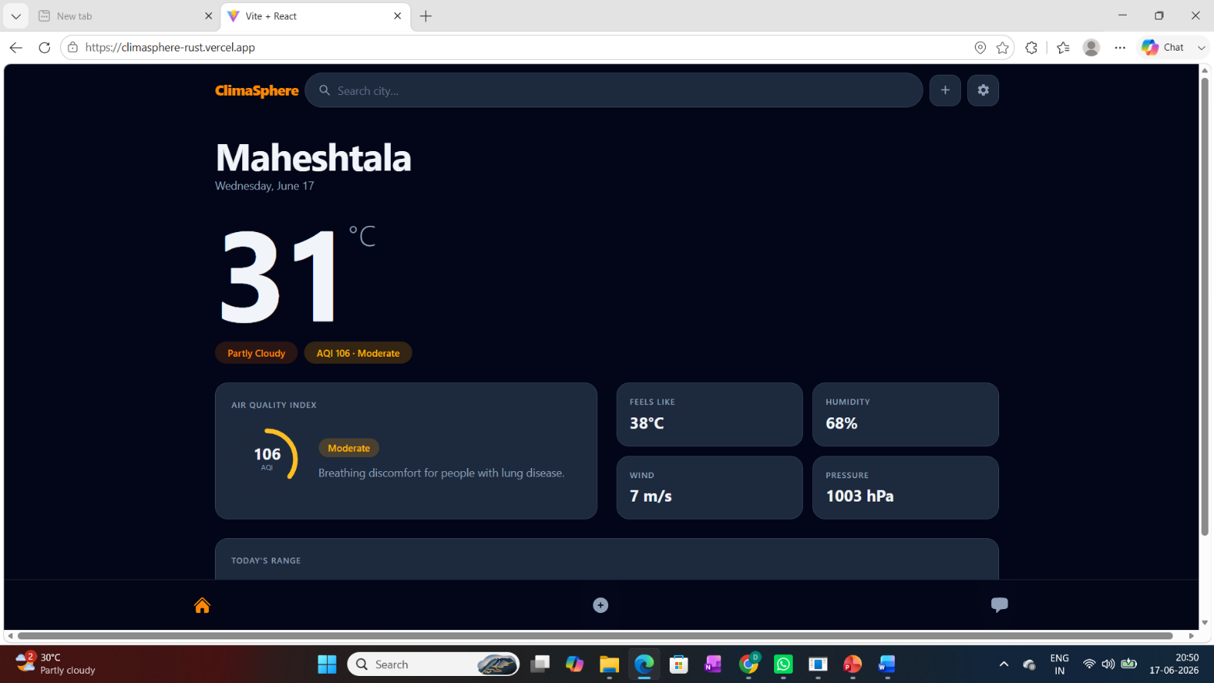

Fig 6.2.1: Home Page of ClimaSphere

Description: The home page serves as the central interface of the ClimaSphere platform, providing users with real-time weather and air quality information for the selected location. It displays key environmental parameters such as temperature, weather condition, Air Quality Index (AQI), humidity, wind speed, atmospheric pressure, and "feels like" temperature in a clean and responsive dashboard. The integrated search bar enables users to quickly search for different cities, while the navigation menu provides seamless access to other modules of the application.

Result: The successful implementation of the home page demonstrates the system's capability to integrate and present real-time weather and air quality data within a single user-friendly interface. By combining multiple environmental parameters into an organized dashboard, the platform enables users to quickly understand current environmental conditions and navigate efficiently to additional analytical and community features, thereby improving the overall user experience.

6.2.2 User Authentication Module
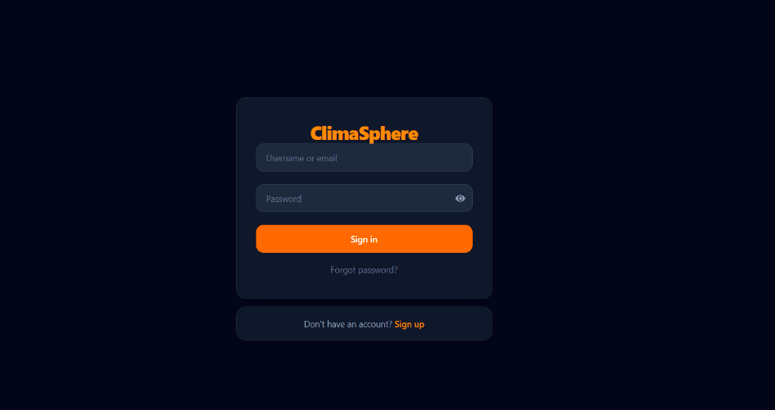

Fig 6.2.2: User Authentication (Sign In / Sign Up) Page

Description: The User Authentication module provides a secure gateway for users to access the ClimaSphere platform. It enables new users to create an account through the Sign Up feature and allows registered users to log in using their credentials via the Sign In page. The interface includes username/email and password fields, password visibility control, and a password recovery option, ensuring a simple and secure authentication process.

Result: The successful implementation of the authentication module ensures that only authorized users can access personalized features of the platform, such as community interaction, analysis uploads, saved locations, and profile management. This module enhances the overall security of the application while providing a seamless and user-friendly login experience.

6.2.3 Community Chat System

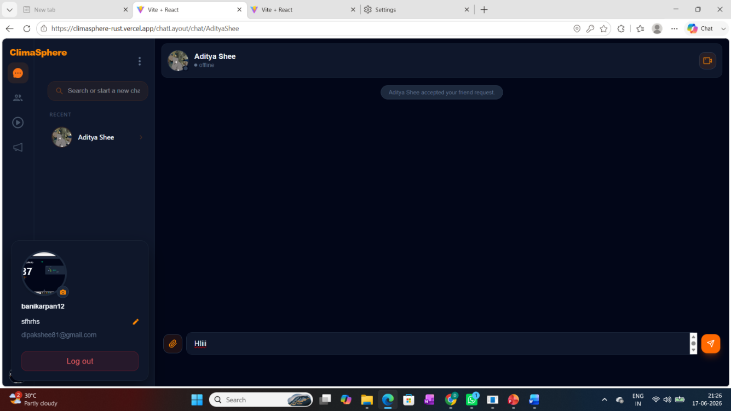

Fig 6.2.3: Community Chat Module
Description: The Community Chat module enables registered users to communicate with other members of the ClimaSphere platform through a secure one-to-one messaging interface. Users can search for contacts, initiate conversations, exchange text messages, and share files or media. The module also displays user profiles, recent chats, and online/offline status, providing a familiar and intuitive communication environment for collaboration and knowledge sharing.

Result: The successful implementation of the Community Chat module extends ClimaSphere beyond a conventional environmental monitoring application by facilitating communication among users, researchers, and environmental enthusiasts. This feature encourages collaboration, discussion, and the exchange of environmental knowledge, creating an interactive community that supports learning and collective awareness.

6.2.4 Analysis & Insights Repository
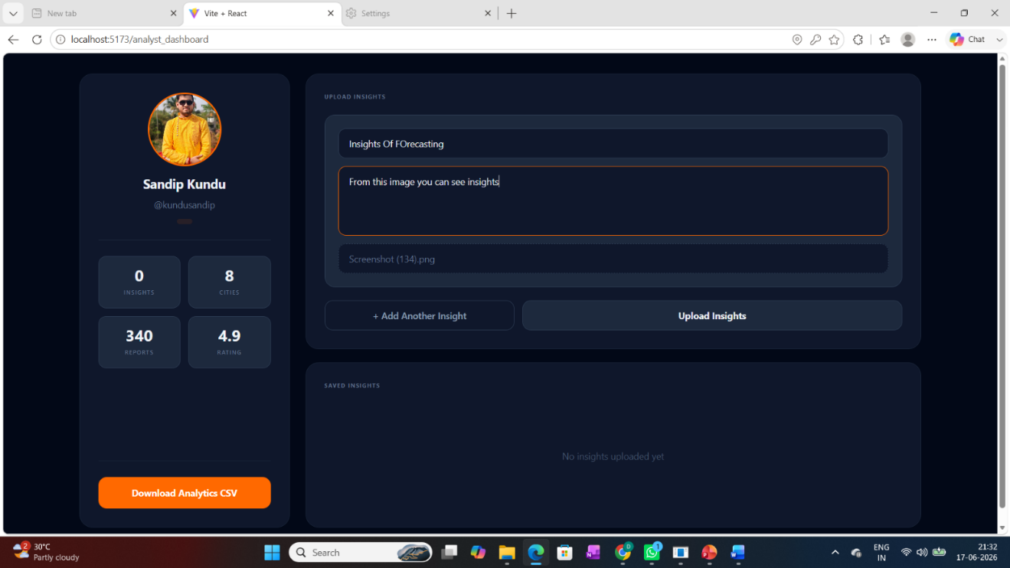

Fig 6.2.4: Analysis & Insights Repository

Description: The Analysis & Insights Repository enables verified analysts and researchers to upload analytical observations, research findings, and environmental insights based on weather and air quality data. Users can provide a title, descriptive analysis, and supporting images before publishing their insights. The module also includes profile statistics and a CSV download feature, allowing users to export analytical datasets for further offline analysis, research, and academic purposes.

Result: The successful implementation of this module transforms ClimaSphere from a conventional environmental monitoring application into a collaborative analytical platform. It encourages users to contribute knowledge, share research findings, and build an accessible repository of environmental insights. The integrated dataset download functionality further supports students, researchers, and data analysts by enabling independent analysis and promoting data-driven environmental research.

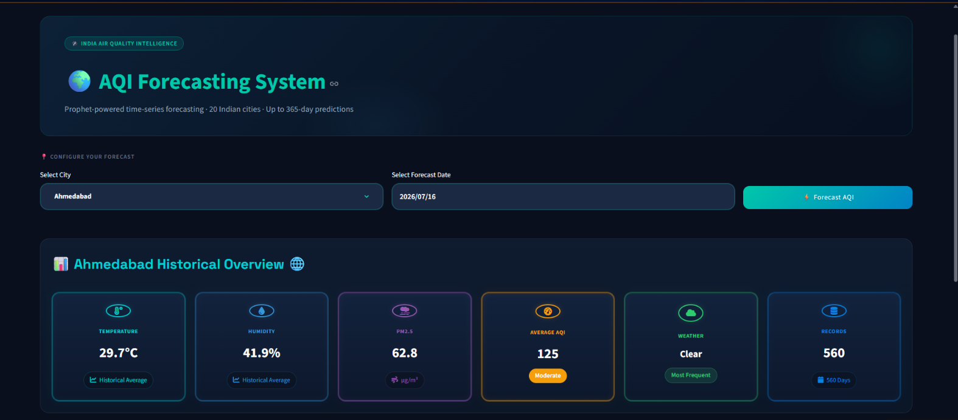
6.2.5 AQI Forecasting System

Fig 6.2.5: AQI Forecasting Platform

Description: The AQI Forecasting System is a dedicated Streamlit-based analytical platform developed to predict future Air Quality Index (AQI) values for selected Indian cities using the Prophet time-series forecasting model. Users can select a city and a target forecast date to generate AQI predictions based on historical environmental data. The platform presents historical city statistics, predicted AQI values, AQI categories, confidence intervals, and interactive visualizations, including forecast trend graphs and monthly AQI pattern analysis, enabling users to understand both current environmental conditions and future air quality trends.

Result: The successful implementation of the AQI Forecasting System demonstrates the capability of ClimaSphere to extend beyond real-time monitoring by providing reliable predictive environmental analytics. The integration of interactive visualizations and statistical forecasting enables users, researchers, and environmental analysts to anticipate future air quality conditions, supporting better planning, environmental awareness, and data-driven decision-making.

6.2.6 Weather Forecasting System

Description: The Weather Forecasting System is a dedicated Streamlit-based forecasting platform developed to predict future weather conditions for selected Indian cities using the Prophet time-series forecasting model. Users can choose a city and forecast date to obtain predicted weather information, including temperature, humidity, wind speed, atmospheric pressure, rainfall probability, and UV index. The dashboard presents these parameters through an intuitive and responsive interface, enabling users to access comprehensive weather forecasts for future dates.

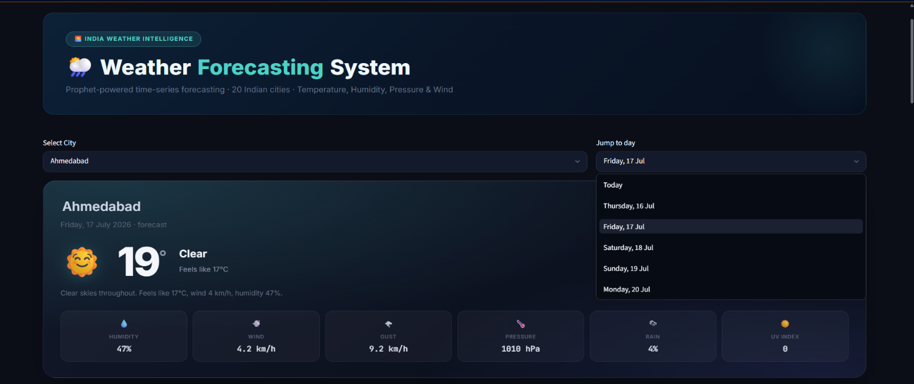
Fig 6.2.7: Weather Forecasting Dashboard
Result: The successful implementation of the Weather Forecasting System demonstrates the platform's capability to generate reliable short-term weather forecasts using historical environmental data. By integrating multiple meteorological parameters into a single dashboard, the system enables users to monitor expected weather conditions and supports informed planning based on predictive analytics.

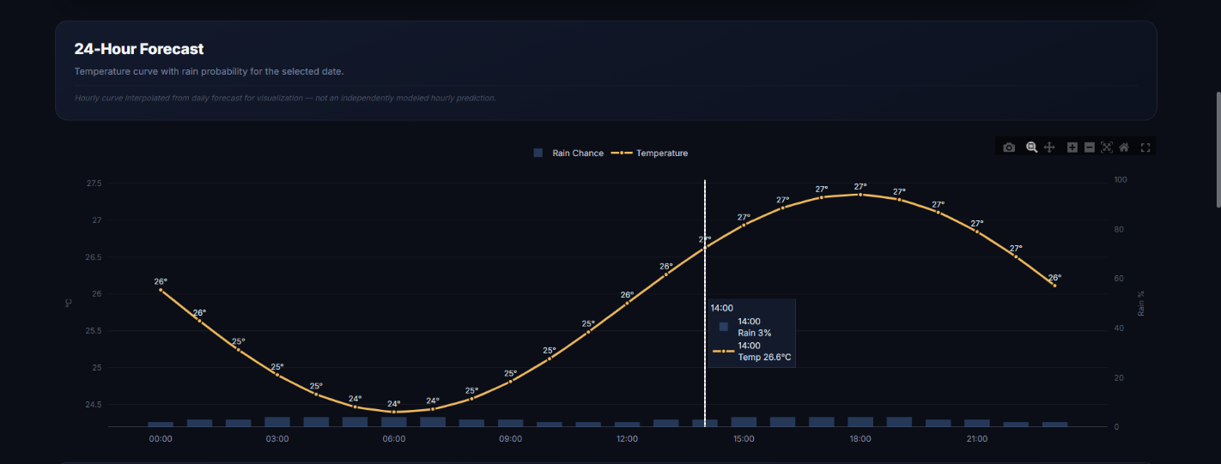

Fig 6.2.7: Visualization & Trend Analysis

Description: The forecasting platform further presents weather predictions through interactive visualizations, including 24-hour temperature trends, rainfall probability, and graphical forecast analysis. These visual representations allow users to examine expected weather variations throughout the selected forecast period, making the prediction results easier to interpret.

Result: The integration of interactive forecast visualizations enhances the interpretability of prediction results and enables users to identify expected temperature fluctuations and weather patterns effectively. This graphical representation improves decision-making by transforming forecast data into clear and meaningful insights.

Table 6.3: Comparative Analysis of ClimaSphere with Existing Applications

Feature | Google Weather | IQAir | Open  Weather | Government AQI Portals | ClimaSphere (Proposed System)
Real-time Weather Data | Available | Limited | Available | Not Available | Available
Real-time AQI Data | Limited | Available | Available | Available | Available
Weather & AQI on a Single Platform | Not Available | Limited | Available | Not Available | Available
AQI Based on Multiple Pollutant | Not Available | Available | Available | Available | Available
Historical Data Access | Not Available | Limited | API Access Only | Available | Available
Historical Data Download (CSV) | Not Available | Not Available | API Access Only | Limited | Available
Exploratory Data Analysis (EDA) | Not Available | Not Available | Not Available | Not Available | Available
Weather Forecasting | Available | Limited | Available | Limited | Available
AQI Forecasting | Not Available | Limited | Not Available | Not Available | Available
Interactive Dashboards & Charts | Limited | Limited | Not Available | Limited | Available
Analysis & Insights Repository | Not Available | Not Available | Not Available | Not Available | Available
Upload Analytical Insights | Not Available | Not Available | Not Available | Not Available | Available
View Analyst Insights | Not Available | Not Available | Not Available | Not Available | Available
Community Chat & Collaboration | Not Available | Not Available | Not Available | Not Available | Available
Voice / Video Calling | Not Available | Not Available | Not Available | Not Available | Available
Social Media & Blog Platform | Not Available | Not Available | Not Available | Not Available | Available
User Authentication & Profiles | Limited | Available | API Account Only | Not Available | Available
Saved Locations | Available | Available | Available | Limited | Available
Real-time Alerts & Notifications | Available | Available | Available | Available | Available
Multi-language Support | Limited | Limited | Available | Limited | Available
Responsive Web Interface | Available | Available | Available | Limited | Available
Student & Research-Oriented Platform | Not Available | Not Available | Not Available | Not Available | Available
Integrated Weather + AQI + Analysis + Forecast + Community Platform | Not Available | Not Available | Not Available | Not Available | Available
Integrated Weather Monitoring, Pollution Analysis, Forecasting & Knowledge Sharing | Not Available | Not Available | Not Available | Not Available | Available

CHAPTER – 7: CONCLUSION AND LESSON LEARNT

7.1 Conclusion

The project titled "An Interactive Real-Time System for Tracking and Analysing Weather and Pollution Patterns" has been successfully designed, developed, and implemented as a comprehensive web-based environmental intelligence platform named ClimaSphere. The proposed system integrates real-time weather monitoring, air quality assessment, historical data management, data analytics, forecasting, and collaborative communication into a unified platform, providing users with an efficient and user-friendly solution for environmental monitoring and analysis. The application was developed using the MERN (MongoDB, Express.js, React.js, and Node.js) technology stack, enabling a responsive, scalable, and secure web application. Real-time environmental information is retrieved using the OpenWeather Weather API and OpenWeather Air Pollution API, allowing users to monitor weather conditions and air quality for locations across the world. In addition, historical datasets for selected Indian cities were utilized to perform Exploratory Data Analysis (EDA) and Prophet-based forecasting, enabling users to visualize environmental trends and predict future weather behaviour and AQI patterns.

Beyond environmental monitoring, ClimaSphere incorporates several innovative features that enhance user engagement and knowledge sharing. These include secure user authentication, interactive dashboards, historical data downloads, an Analysis & Insights Repository, community chat, voice and video communication, media sharing, social blogging, notifications, multilingual support, and personalized user profiles. The integration of these modules transforms the platform from a conventional weather application into a collaborative environmental intelligence system that supports researchers, environmental analysts, students, government agencies, NGOs, and the general public. The objectives defined at the beginning of the project have been successfully achieved. The developed platform demonstrates the effective integration of modern web technologies with data analytics and forecasting techniques, providing meaningful environmental insights while maintaining a responsive and intuitive user experience. The modular architecture adopted during development ensures that the system is scalable, maintainable, and capable of supporting future enhancements without significant modifications to the existing framework.

Overall, ClimaSphere provides a practical and innovative solution for environmental monitoring by combining real-time environmental data, analytical visualization, predictive forecasting, and collaborative knowledge sharing within a single platform. The project demonstrates how modern web technologies and data-driven methodologies can be effectively applied to address real-world environmental challenges while promoting public awareness, supporting environmental research, and encouraging informed decision-making. With its flexible architecture and extensible design, the platform establishes a strong foundation for future advancements in intelligent environmental monitoring systems.
7.2 Lessons Learnt

Throughout the development of ClimaSphere, valuable technical, analytical, and project management skills were acquired. The project provided practical exposure to designing and implementing a full-stack web application while integrating real-time environmental data, data analytics, and forecasting techniques. The major lessons learnt during the project are summarized below:
- Full-Stack Web Development: Gained hands-on experience in developing a complete MERN stack application, including frontend design, backend development, database management, and RESTful API integration.
- Real-Time API Integration: Learned how to retrieve, validate, process, and manage live environmental data from external APIs while handling asynchronous requests and error scenarios.
- Data Analytics & Visualization: Enhanced practical knowledge of data preprocessing, exploratory data analysis (EDA), statistical interpretation, and data visualization using Python libraries.
- Time-Series Forecasting: Developed an understanding of time-series forecasting using the Prophet model and learned how historical environmental data can be used to predict future weather behaviour and AQI trends.
- Database Design & Management: Improved skills in designing MongoDB collections, managing document-based databases, and organizing application data efficiently.
- Software Design & System Architecture: Learned the importance of modular system architecture, component interaction, scalability, maintainability, and structured software development practices.
- Problem Solving & Debugging: Strengthened debugging, testing, and troubleshooting skills while resolving issues related to API integration, database operations, forecasting models, and user interface development.
- Teamwork & Project Management: Improved collaboration, task coordination, documentation, and project planning skills through the systematic execution of different development phases.
- Environmental Awareness: Developed a deeper understanding of environmental monitoring, air quality assessment, and the importance of data-driven decision-making for promoting public awareness and sustainable environmental practices.
Overall, the project served as an excellent learning experience by combining software engineering, data analytics, forecasting, and collaborative application development into a single real-world solution. The knowledge and practical skills gained through this project will provide a strong foundation for future academic research and professional careers in software engineering, data analytics, and environmental technology.

CHAPTER – 7: Recommendations & Suggestions

8.1 Recommendations

The proposed ClimaSphere platform has been successfully developed as an integrated environmental intelligence system. However, several recommendations can further improve its performance, usability, and practical applicability.

1. Data Collection & Data Quality Enhancement: Although the system successfully collects real-time environmental data using the OpenWeather APIs, future versions should integrate multiple trusted environmental data sources and official government datasets to improve data accuracy, reliability, and geographical coverage. Implementing automatic data validation and quality assessment techniques would further enhance the credibility of analytical results.

2. Advanced Forecasting Models: The current forecasting module utilizes the Prophet time-series forecasting model to predict weather behaviour and AQI trends. Future improvements may include integrating advanced machine learning and deep learning models such as LSTM, GRU, XGBoost, and Transformer-based architectures to improve forecasting accuracy, especially during sudden environmental changes and extreme weather conditions.

3. Intelligent Environmental Analytics: The platform can be enhanced by incorporating Artificial Intelligence techniques capable of automatically identifying pollution hotspots, detecting abnormal environmental events, generating personalized environmental insights, and recommending preventive actions based on historical trends and real-time environmental conditions.

4. Improved User Experience: The user interface can be further enhanced by providing greater personalization, customizable dashboards, dark mode, accessibility features, interactive maps, and location-based recommendations to improve overall usability and user engagement.

5. Enhanced Collaboration Platform: The Analysis & Insights Repository and Community Platform can be expanded by introducing expert verification, discussion forums, collaborative research workspaces, document sharing, peer review mechanisms, and reputation-based contributor systems to strengthen knowledge sharing among researchers and environmental professionals.

6. Security & Privacy Enhancement: Future versions should incorporate multi-factor authentication (MFA), advanced encryption techniques, secure API gateways, audit logging, and role-based access control to further improve application security and protect sensitive user information.

7. Scalability & Cloud Deployment: To support larger user communities, the application should be deployed using scalable cloud infrastructure with containerization technologies such as Docker and orchestration platforms like Kubernetes. It improves system availability, performance, and fault tolerance.

8.2 Future Scope

The proposed ClimaSphere platform has been developed using a modular architecture, enabling future enhancements without major changes to the existing system. Although the current implementation provides real-time environmental monitoring, forecasting, data visualization, and collaborative features, several improvements can further enhance its functionality, scalability, and user experience. Some potential future developments are presented below.

1. Expansion of Historical Dataset Coverage: The current analytical module utilizes historical datasets collected from selected Indian cities. Future versions can incorporate datasets from additional cities and states, enabling more comprehensive regional analysis and environmental comparisons.
2. Enhanced Forecasting Models: Future work may evaluate advanced machine learning and deep learning models alongside the existing Prophet model to improve forecasting accuracy and support comparative performance analysis.
3. Personalized Environmental Alerts: Users can be provided with customizable alerts for AQI levels, weather changes, rainfall predictions, and extreme temperature conditions based on their preferred locations.
4. Interactive Environmental Maps: The integration of interactive map services can provide location-based visualization of weather conditions, air quality, and pollution levels, improving geographical analysis and user understanding.
5. Advanced Dashboards and Data Visualization: Future versions can include additional analytical dashboards, interactive filters, comparison tools, and customizable visualizations to support more detailed environmental analysis.
6. Mobile Application Development: A dedicated Android and iOS application can be developed to provide seamless access to real-time weather updates, AQI monitoring, forecasting, and notifications on mobile devices.
7. Enhanced Research and Knowledge Sharing: The Analysis & Insights Repository can be expanded to support detailed research reports, case studies, advanced search, bookmarking, and resource sharing, further promoting collaboration and environmental awareness.
8. Multi-Language Expansion: Support for additional regional and international languages can improve accessibility and extend the platform's reach to a broader user community.
9. Performance Optimization: Future enhancements may focus on improving system performance, scalability, and responsiveness through optimized data processing, efficient resource management, and enhanced application performance.

REFERENCES
[[1] S. J. Taylor and B. Letham, "Forecasting at scale," The American Statistician, vol. 72, pp. 37-48, 2018.
[2] Ramadan, M. A., Alharthi, M., Alghamdi, H., & Alzahrani, M. (2024). Real- time IoT-powered AI system for monitoring and forecasting environmental conditions. IEEE Access.
[3] Collado, M., Cabrera, C., & López, D. (2024). Open-source IoT-based air pollution monitoring system. International Journal of Environmental Monitoring, 12(3), 45–56.
[4] Rahmadani, F., Widyawan, A., & Nugraha, A. (2024). Real-Time Air Quality Monitoring through IoT and Web Platform. MDPI Sensors, 24(6), 3251.
[5] Rajesh, A., Kumar, S., & Rao, P. (2025). Machine learning-driven framework for real-time air quality assessment and health risk prediction. Scientific Reports, 15(1), 10213.
[6] Lu, F., Liu, Q., & Zhao, J. (2017). An Interactive Web Mapping Visualization of Urban Air Quality Data. Atmosphere, 8(9), 173.
[7] React, React Documentation. [Online]. Available: https://react.dev
[8] Node.js Foundation, Node.js Documentation. [Online]. Available: https://nodejs.org/en/docs
[9] Express.js, Express.js Documentation. [Online]. Available: https://expressjs.com
[10] MongoDB Inc., MongoDB Documentation. [Online]. Available: https://www.mongodb.com/docs
[11] Streamlit Inc., Streamlit Documentation. [Online]. Available: https://docs.streamlit.io
[12] Prophet Development Team, Documentation. [Online]. Available: https://facebook.github.io/prophet
[13] W. McKinney, Python for Data Analysis, 3rd ed. Sebastopol, CA: O'Reilly Media, 2022.
[14] C. R. Harris et al., "Array programming with NumPy," Nature, vol. 585, no. 7825, pp. 357–362, 2020.
[15] Pandas Development Team, Documentation. [Online]. Available: https://pandas.pydata.org/docs
[16] J. D. Hunter, "Matplotlib: A 2D graphics environment," Computing in Science & Engineering, vol. 9, no. 3, pp. 90–95, 2007.
[17] M. L. Waskom, "Seaborn: Statistical data visualization," Journal of Open Source Software, vol. 6, no. 60, p. 3021, 2021.
[18] Plotly Technologies Inc., Plotly Python Documentation. [Online]. Available: https://plotly.com/python
[19] F. Pedregosa et al., "Scikit-learn: Machine learning in Python," Journal of Machine Learning Research, vol. 12, pp. 2825–2830, 2011.
[20] Chart.js, Chart.js Documentation. [Online]. Available: https://www.chartjs.org/docs
[21] Socket.IO, Socket.IO Documentation. [Online]. Available: https://socket.io/docs
[22] JWT.io, JSON Web Token (JWT) Introduction. [Online]. Available: https://jwt.io/introduction
[23] Cloudinary, Cloudinary Documentation. [Online]. Available: https://cloudinary.com/documentation
[24] Postman Inc., Postman Learning Center. [Online]. Available: https://learning.postman.com
APPENDICES / ANNEXURES

Appendix A – Project Development Timeline

A.1 Overview: The project was developed over a period of 48 weeks (August 2025 – July 2026), following a phased development approach. The work progressed from requirement gathering and planning, through core infrastructure setup, feature-by-feature development (authentication, weather/AQI integration, community features, real-time chat, analyst dashboard), and concluded with testing, documentation, and final submission.

A.2 Phase-wise Summary
Phase | Duration | Weeks | Key Deliverables
1. Planning & Requirement Analysis | 1–31 Aug 2025 | Week 1–4 | Problem identification, team roles, literature survey, tech stack finalization (MERN, Tailwind, WebSocket, JWT, Cloudinary), SRS document
2. Project Setup & Architecture | 1–21 Sep 2025 | Week 5–7 | Git repository, frontend/backend initialization, React/Vite/Express/MongoDB configuration, UI wireframes
3. Core UI & Authentication | 22 Sep–31 Oct 2025 | Week 8–12 | Landing page, navigation, registration/login, JWT authentication, protected routes, user schema, profile management
4. File Handling & Weather/AQI Integration | 1 Nov–31 Dec 2025 | Week 13–20 | Cloudinary configuration, file upload testing, OpenWeather Weather & Air Pollution API integration, search/filter features, bug fixes
5. Community Features (Posts & Comments) | 1–31 Jan 2026 | Week 21–24 | Post/comment database schema, CRUD operations for posts, commenting system, image attachments
6. Real-Time Chat System | 1–28 Feb 2026 | Week 25–28 | WebSocket-based real-time chat, online status, message delivery, file sharing, UI improvements
7. Data Analyst Dashboard & Forecasting | 1–31 Mar 2026 | Week 29–32 | Data download (CSV/JSON), download history, Data Analyst dashboard design, insights upload module
8. Forecasting & Visualization | 1–30 Apr 2026 | Week 33–36 | Forecasting module, charts and data visualization, dashboard usability improvements, integration testing
9. Bug Fixing & Optimization | 1–31 May 2026 | Week 37–40 | Authentication/API bug fixes, security and validation improvements, database query optimization, accessibility enhancements
10. Testing & User Feedback | 1–30 Jun 2026 | Week 41–44 | Module testing, user acceptance testing (UAT), UI/UX refinement based on feedback, final bug fixes
11. Documentation & Final Submission | 1–31 Jul 2026 | Week 45–48 | Technical & API documentation, testing report, screenshots, user manual, final code review, deployment testing, presentation.

A.3 Detailed Week-wise Log
Week | Timeline | Work Completed
1 | 1–7 Aug 2025 | Project idea discussion, problem identification, requirement gathering, team role distribution
2 | 8–14 Aug 2025 | Literature survey on environmental monitoring systems and similar web applications
3 | 15–21 Aug 2025 | Finalized project scope; selected MERN Stack, Tailwind CSS, WebSocket, JWT, and Cloudinary
4 | 22–31 Aug 2025 | Prepared Software Requirement Specification (SRS); designed initial workflow and milestones
5 | 1–7 Sep 2025 | Created Git repository; initialized frontend and backend projects
6 | 8–14 Sep 2025 | Configured React, Vite, Express.js, MongoDB, and project folder structure
7 | 15–21 Sep 2025 | Designed UI wireframes and responsive layouts using Tailwind CSS
8 | 22–30 Sep 2025 | Developed landing page and navigation components
9 | 1–7 Oct 2025 | Implemented user registration and login pages
10 | 8–14 Oct 2025 | Integrated JWT authentication and protected routes
11 | 15–21 Oct 2025 | Created MongoDB schemas for users and authentication
12 | 22–31 Oct 2025 | Implemented profile management and user settings
13 | 1–7 Nov 2025 | Configured Cloudinary for image and file uploads
14 | 8–14 Nov 2025 | Tested file upload functionality and optimized storage
15 | 15–21 Nov 2025 | Integrated OpenWeather Weather API
16 | 22–30 Nov 2025 | Integrated OpenWeather Air Pollution API
17 | 1–7 Dec 2025 | Displayed weather information with responsive UI
18 | 8–14 Dec 2025 | Displayed pollution index and environmental indicators
19 | 15–21 Dec 2025 | Added search by city/location and filtering features
20 | 22–31 Dec 2025 | Fixed API integration bugs and improved performance
21 | 1–7 Jan 2026 | Designed database schema for posts and comments
22 | 8–14 Jan 2026 | Developed post creation, update, and delete features
23 | 15–21 Jan 2026 | Implemented commenting system
24 | 22–31 Jan 2026 | Added image attachments to environmental posts
25 | 1–7 Feb 2026 | Implemented real-time chat using WebSocket
26 | 8–14 Feb 2026 | Added online user status and message delivery
27 | 15–21 Feb 2026 | Developed real-time file sharing through WebSocket
28 | 22–28 Feb 2026 | Improved chat interface and messaging experience
29 | 1–7 Mar 2026 | Implemented data download functionality (CSV/JSON)
30 | 8–14 Mar 2026 | Added download history and validation
31 | 15–21 Mar 2026 | Designed Data Analyst dashboard
32 | 22–31 Mar 2026 | Implemented insights upload module
33 | 1–7 Apr 2026 | Added forecasting module for Data Analyst
34 | 8–14 Apr 2026 | Developed charts and environmental data visualization
35 | 15–21 Apr 2026 | Improved dashboard usability and responsiveness
36 | 22–30 Apr 2026 | Performed integration testing across all modules
37 | 1–7 May 2026 | Fixed authentication and API related bugs
38 | 8–14 May 2026 | Improved security, validation, and error handling
39 | 15–21 May 2026 | Optimized database queries and backend performance
40 | 22–31 May 2026 | Enhanced frontend responsiveness and accessibility
41 | 1–7 Jun 2026 | Conducted module testing by team members
42 | 8–14 Jun 2026 | Conducted user acceptance testing (UAT)
43 | 15–21 Jun 2026 | Collected feedback and improved UI/UX
44 | 22–30 Jun 2026 | Fixed remaining bugs and optimized application flow
45 | 1–7 Jul 2026 | Prepared technical documentation and API documentation
46 | 8–14 Jul 2026 | Completed testing report, screenshots, and user manual
47 | 15–17 Jul 2026 | Final code review, deployment testing, and backup
48 | 20 Jul 2026 | Final project submission, presentation preparation, report completion, and appendices compilation

Appendix B – Development Tools, Technologies & Package Versions

B.1 Overview: This appendix lists the complete set of tools, frameworks, and packages used in the development, testing, and deployment of the project. The stack follows the MERN (MongoDB, Express.js, React, Node.js) architecture, supplemented with real-time communication, authentication, file-handling, and code-quality tools to support a full-featured, production-ready application.

B.2 Development Environment & Version Control
Sl. No. | Tool | Version | Purpose
1 | Node.js | v22.x LTS | JavaScript runtime for backend development
2 | npm | v10.x | Package manager for installing dependencies
3 | Visual Studio Code | Latest | Source code editor
4 | Git | v2.x | Version control system
5 | GitHub | Latest | Source code repository and collaboration

B.3 Database Layer
Sl. No. | Tool | Version | Purpose
6 | MongoDB Community Server | v8.x | NoSQL database
7 | MongoDB Compass | Latest | MongoDB GUI for database management
12 | Mongoose | v8.x | MongoDB Object Data Modeling (ODM)

B.4 Frontend Stack
Sl. No. | Tool | Version | Purpose
8 | React | v19.x | Frontend JavaScript library
9 | Vite | v7.x | Frontend build tool and development server
10 | Tailwind CSS | v4.x | Utility-first CSS framework
26 | React Router DOM | v7.x | Client-side routing
27 | React Hook Form | v7.x | Form validation and management
28 | Lucide React | v0.5xx | Icons for React UI
29 | React Hot Toast | v2.x | Toast notifications

B.5 Backend Stack
Sl. No. | Tool | Version | Purpose
11 | Express.js | v5.x | Backend web framework
22 | Express Async Handler | v1.x | Simplified async error handling
19 | dotenv | v17.x | Environment variable management
20 | CORS | v2.x | Cross-Origin Resource Sharing configuration
21 | cookie-parser | v1.x | Parse HTTP cookies

B.6 Real-Time Communication
Sl. No. | Tool | Version | Purpose
13 | Socket.IO | v4.x | Real-time chat and file sharing using WebSockets

B.7 Authentication & Security
Sl. No. | Tool | Version | Purpose
14 | JSON Web Token (jsonwebtoken) | v9.x | User authentication and authorization
15 | bcrypt | v6.x | Password hashing and security

B.8 File & Media Handling
Sl. No. | Tool | Version | Purpose
16 | Multer | v2.x | Handling multipart/form-data file uploads
17 | Cloudinary SDK | v2.x | Cloud storage for images and files

B.9 API Communication & External Data
Sl. No. | Tool | Version | Purpose
18 | Axios | v1.x | HTTP client for API requests
30 | OpenWeather API | Latest | Weather and air pollution data provider

B.10 Code Quality & Development Tools
Sl. No. | Tool | Version | Purpose
23 | Nodemon | v3.x | Automatic backend server restart during development
24 | ESLint | v9.x | JavaScript code linting
25 | Prettier | v3.x | Code formatting

